

VA FILEMAN

GETTING STARTED MANUAL

Version 22.0

March 1999

Revised June 2009

Department of Veterans Affairs
Office of Information and Technology (OI&T)
Office of Enterprise Development (OED)

Revision History

Document Revision History

The following table displays the revision history for this document. Revisions to the documentation are based on a continuous dialogue with the Infrastructure and Security Services (ISS) Technical Writers and evolving industry standards and styles.

Date | Description | Author
03/1999 | Version 22.0 release. | Tami Winn, San Francisco ISF; Michael Ogi, San Francisco ISF;Thom Blom, San Francisco ISF
12/20/04 | Updated documentation in compliance with new conventions for displaying TEST data. See Orientation section for details. | Susan Strack, Oakland OIFO
6/2006 | Update documentation to make current with online format of the same manual at:  http://vista.med.va.gov/fileman/docs/u1/index.shtml | Susan Strack, Oakland OIFO; Jack Schram, Project Manager; Oakland OIFO
6/2009 | Replace accent grave mark (`), which was being used incorrectly to signify NOT, with the single quote mark (').  Remedy Ticket 304834 | Susan Strack & Gary Beuschel, both from Oakland OIFO; Jack Schram, Project Manager; Oakland OIFO
Table i: Documentation revision history

Patch History

For the current patch history related to this software, please refer to the Patch Module (i.e., Patch User Menu [A1AE USER]) on FORUM.

Preface

The VA FileMan Getting Started Manual is designed to provide you, the VISTA user, with "how to" information on the functions of VA FileMan, VISTA's database management system. The features of VA FileMan are used throughout most VISTA applications.

This manual shows how to use the features of VA FileMan that are likely to be used by all VISTA users. It introduces basic VA FileMan concepts, and shows you how to use VA FileMan's basic tools for displaying and editing data.

The VA FileMan User Manual is comprised of two separate HTML (Hypertext Markup Language) documents:
- The VA FileMan Getting Started Manual (this manual) shows how to use VA FileMan features that are likely to be used by all VISTA users.
 Also available in Hypertext Markup Language (HTML) format.
- The VA FileMan Advanced User Manual describes features that are more likely to be used by ADPACs (ADP Application Coordinators), IRM staff, and other technical users.
Available in Hypertext Markup Language (HTML) format.

Manuals in HTML

Why produce HTML (Hypertext Markup Language) editions of the VA FileMan User Manuals?
- The HTML versions of the VA FileMan manuals are useful as online documentation support as you use VA FileMan. HTML manuals allow you to instantly jump (link) to specific topics or references online.
- The VA FileMan HTML manuals are "living" documents that are continuously updated with the most current VA FileMan information (unlike paper or printed documentation). They are updated based on new versions, patches, or enhancements to VA FileMan.
- Presenting manuals in an HTML format on a web server also gives new opportunities, such as accessing embedded multimedia training material (e.g., movies) directly in the manuals themselves.
- Providing manuals in a native online format (HTML) also helps introduce HTML and web servers to the VISTA user community as documentation platforms for VHA.
- As more user workstations become network-capable, access to information in these HTML manuals is increased by making them available over the VA network.

Table of Contents

Orientation Orientation-ix
Introduction Introduction-1
Part I: Displaying Information I-1
1. Inquire 1-1
2. Print 2-1
Sorting 2-3
Choosing Print Fields 2-14
Other Print Features 2-25
3. Search 3-1
Search Steps 3-2
Details and Features 3-8
4. The Browser 4-1
Browser Features 4-2
Part II: Editing Records II-1
5. VA FileMan Prompts 5-1
Special Responses to Field Prompts 5-9
6. About Each Field Type 6-1
7. Adding and Deleting Records 7-1
8. ScreenMan 8-1
Cursor Movement (Navigation Keystrokes) 8-3
Editing 8-6
Details 8-13
Part III: WORD-PROCESSING Fields III-1
9. Choice of Word Processing Editors 9-1
10. Screen Editor 10-1
Troubleshooting 10-10
Screen Editor and Personal Computers 10-11
11. Line Editor 11-1
Commands 11-5
Advanced Features 11-8
Glossary Glossary-1
Index Index-1

Orientation

Installation of VA FileMan in the Veterans Health Information Systems and Technology Architecture (VISTA) environment is described in the VA FileMan Installation Guide and in the description of the patch being released.

How to Use this Manual

This manual uses several methods to highlight different aspects of the material:
- Descriptive text is presented in a proportional font (as represented by this font).
- Conventions for Displaying TEST Data in this Document are as Follows:
- The first three digits (prefix) of any Social Security Numbers (SSN) will begin with either "000" or "666".
- Patient and user names will be formatted as follows: [Application Name]PATIENT,[N] and [Application Name]USER,[N] respectively, where "Application Name" is defined in the Approved Application Abbreviations document, located on the [web site] and where "N" represents the first name as a number spelled out and incremented with each new entry. For example, in FileMan, test patient and user names would be documented as follows: FMPATIENT,ONE; FMPATIENT,TWO; FMPATIENT,10; etc. and FMUSER,ONE; FMUSER,TWO; FMUSER,10; etc.

 | The list of Approved Application Abbreviations can be found at the following Web site:  http://vista.med.va.gov/iss/strategic_docs.asp#sop

- "Snapshots" of computer online displays (i.e., character-based screen captures/dialogues) and computer source code are shown in a non-proportional font and enclosed within a box. Also included are Graphical User Interface (GUI) Microsoft Windows images (i.e., dialogues or forms).
- User's responses to online prompts will be boldface.
- The "<Enter>" found within these snapshots indicate that the user should press the Enter or Return key on their keyboard.
- All uppercase is reserved for the representation of M code, variable names, or the formal name of options, field/file names, and security keys (e.g., the XUPROGMODE key).

Other software code (e.g., Delphi/Pascal and Java) variable names and file/folder names can be written in lower or mixed case.
- Three symbols are used throughout the documentation to alert the reader to special information. The following table gives a description of each of these symbols:

Symbol | Description
 | Used to inform the reader of general information including references to additional reading material.
 | Used to caution the reader to take special notice of critical information.
 | Used to inform the reader of helpful tips or tricks they can use when working with VA FileMan.
Table 1: Documentation Symbol Descriptions

Assumptions About the Reader

This manual is written with the assumption that the reader is familiar with the VISTA computing environment. If you need more information, we suggest you look at the various VA home pages for a general orientation to VISTA. You might want to begin here:
- Office of Enterprise Development - VistA & HealtheVet Development http://vaww.vista.med.va.gov/

Related Manuals and Other References

Readers who wish to learn more about VA FileMan should consult the manuals listed below, which are located on the VHA Software Document Library (VDL) (http://www.va.gov/vdl/application.asp?appid=5) in MS-Word and PDF formats:
- VA FileMan V. 22.0 Release Notes (PDF format)
- VA FileMan V. 22.0 Installation Guide (PDF format)
- VA FileMan V. 22.0 Technical Manual (PDF format)
- VA FileMan V. 22.0 Programmer Manual (PDF format, also in HTML format)
- VA FileMan V. 22.0 Advanced User Manual (PDF format, also in HTML format)

VA FileMan documentation in HTML format is located on the VA FileMan Product page:
- http://vaww.vista.med.va.gov/fileman/index.asp

Using the web browser, open the HTML documents "table of contents" page (i.e., INDEX.HTML). The distinguishing characteristic of manuals in this format are the hypertext jumps contained within the text. Clicking on a hypertext jump causes your browser to jump to the location or document described in the jump. The VA FileMan Getting Started Manual, the VA FileMan Advanced User Manual, and the VA FileMan Programmer Manual are all linked together.

The .PDF documents must be read using the Adobe Acrobat Reader (i.e., ACROREAD.EXE), which is also freely distributed by Adobe Systems Incorporated at the following web address:
http://www.adobe.com/

Introduction

What is VA FileMan?

VA FileMan creates and maintains a database management system that includes features such as:
- A report writer
- A data dictionary manager
- Scrolling and screen-oriented data entry
- Text editors
- Programming utilities
- Tools for sending data to other systems
- File archiving

VA FileMan can be used as a standalone database, as a set of interactive or "silent" routines, or as a set of application utilities; in all modes, it is used to define, enter, and retrieve information from a set of computer-stored files, each of which is described by a data dictionary.

VA FileMan is a public domain software package that is developed and maintained by the Department of Veterans Affairs. It is widely used by VA medical centers and in clinical, administrative, and business settings in this country and abroad.

The VA FileMan Development Team encourages you to send to them questions and comments about the completeness and accuracy of this manual and suggestions for its improvement.

 | Programmer access in VistA is defined as DUZ(0)="@". It grants the privilege to become a programmer in VistA. Programmer access allows you to work outside many of the security controls enforced by VA FileMan, enables access to all VA FileMan files, access to modify data dictionaries, etc. It is important to proceed with caution when having access to the system in this way.

Fields, Records, and Files

A computer database such as VA FileMan organizes your data, storing it in fields, records, and files, much as you might arrange and preserve information on paper.

A record is a group of fields of data. Each record has a name (e.g., a patient name for a patient record). You can use the record name to recall the record for editing or for printing out. Records are also known as file entries.

For example, a record for a patient might have various fields such as NAME, AGE, ADMISSION DATE, etc. for a single patient. Each record for a patient would contain the same set of fields (places to fill in information):

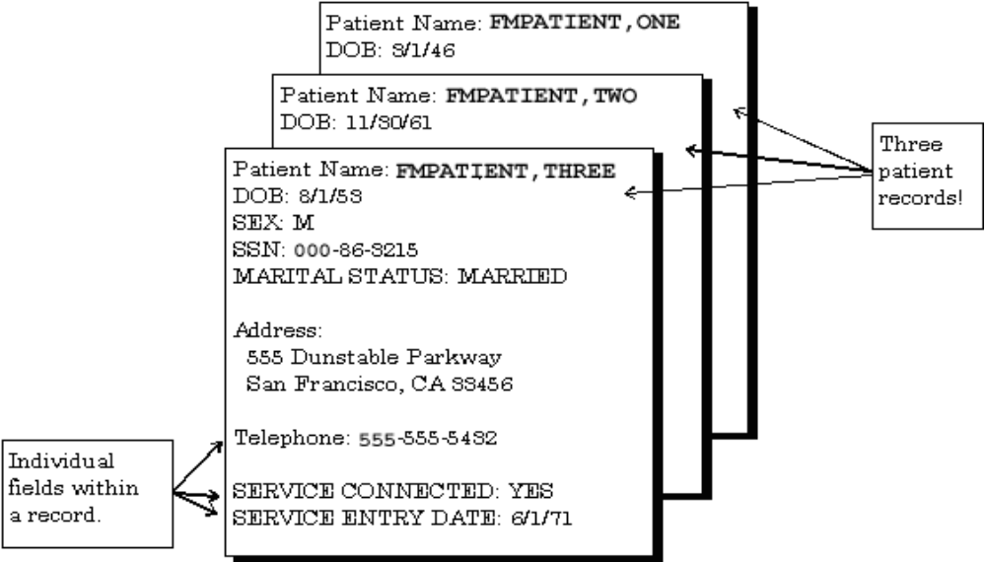
Figure 1: An Example Showing Several Patient Records

Each field in a record functions just like a blank on a form. When you're editing a record on a terminal, for each field, you'll find a prompt that tells you what type of data to enter.

VA FileMan uses nine basic field types. These fields allow you to enter only certain kinds of information, just as a blank on a form might require you to enter only numbers. For example, a DATE OF BIRTH field could be set up to record dates/times; a SOCIAL SECURITY NUMBER field could be set up to record a nine-digit number; an ADDRESS field could be set up to hold the text of an address. These three fields are different from one another because of the type of data they store.

All of the records that contain like data are collected and stored in the same file. For example, all patient records are stored in the PATIENT file (#2) and all computer user records are stored in the NEW PERSON file (#200). This way, to look up a patient, you know that the file to go to is the PATIENT file. Also, to do a report on all patients, you would generate the report from the PATIENT file.

Files and the Database

The database contains all the data files on your computer system:

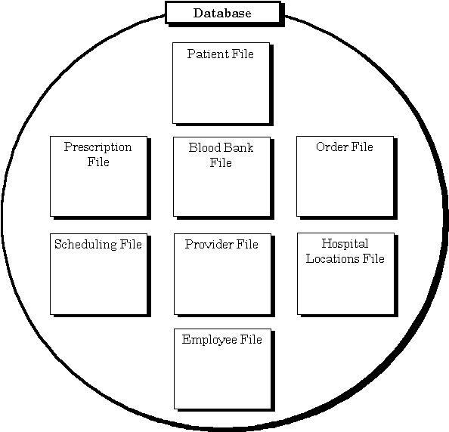
Figure 2: A Representation of a Database

There are many more files than this in VISTA databases!

Printing Records from Files

One way of getting at the information stored in a database is to generate reports that print out selected records. You don't have to print every field in a record; you can just choose a subset of fields to print out. Nor do you have to print every record in a file; there are ways to limit and select what records to print out.

The following report displays four records, with one line of output per record, from the HOSPITAL LOCATION file (#44):

Internal Entry
Number Name Title
------------- ---------- -------------------
1 ICU Intensive Care Unit
2 CCU Critical Care Unit
5 OR Operating Room
25 1EAST Ward on 1 East
Figure 3: An Example of a Printed Report

Most applications that use VA FileMan provide a number of already-set-up reports you can quickly choose and print out. In addition, there are options in VA FileMan that allow you to generate your own reports.

This manual contains the following chapters on print records from the database:
- Chapter 1—Inquire
- Chapter 2—Print
- Chapter 3—Search
- Chapter 4—The Browser

Adding and Editing Records

As well as printing records from the database, you can add new records and edit existing records. When you work on the computer system with VISTA applications (e.g., Laboratory) most of what you are doing is adding new records and editing existing ones. For example, each new lab result would get stored in a new record; when you make a status change it would be an edit to a field or fields in a patient's existing record.

Since the bulk of the work you do on the computer system involves working with records, the more you know about using the underlying database system (VA FileMan), the easier it will be do all of your work on the computer system.

This manual contains the following chapters on how to edit information in records:
- Chapter 5—VA FileMan Prompts
- Chapter 6—About Each Field Type
- Chapter 7—Adding and Deleting Records
- Chapter 8—ScreenMan (editing via forms)
- Chapter 9—Choice of Word Processing Editors
- Chapter 10—Screen Editor (WORD-PROCESSING fields)
- Chapter 11—Line Editor (WORD-PROCESSING fields)

LAYGO File Access

In VISTA applications, you not only display and edit existing records, but also add and delete records from files. For example, you might need to add a new patient to the PATIENT file. The access to add and delete records can be controlled, however; each VA FileMan file can be set to either allow or not allow adding and deleting of new records.

If a file allows records to be added or deleted, it is said to have LAYGO (Learn-As-You-Go) access. To add or delete records, your user account must also be set to allow LAYGO access to the file in question. For example, there are certain conditions when you need to specify a particular physician. At that point, you can enter a new physician name, rather than choosing one that already is on file. If you are allowed to add new entries to the file (i.e., you have LAYGO access), the new entry is added to a file of physicians.

Scrolling Mode vs. Screen Mode

Many VA VISTA application packages have a Scrolling Mode interface. Scrolling Mode works as follows:
- The computer puts a prompt on your screen.
- You enter a response to the prompt.
- The computer places another prompt on the screen, scrolling down one line. Previous prompts move up and eventually off of your screen.

In Scrolling Mode, prompting occurs in the same predetermined order, in a sequence designed by the developer of the application. You enter, and the computer stores, your responses one at a time. Unless you're familiar with a few timesaving Scrolling Mode techniques, you have to step through each prompt in a record before you can finish editing the record.

For more information on editing records in Scrolling Mode, please refer to Chapter 5, the "VA FileMan Prompts," in this manual.

Recently developed VISTA applications, on the other hand, often use a Screen Mode interface for editing data. In the Screen Mode approach, each field occupies a fixed position on the screen. You can see many data fields at once, and use simple key combinations to edit data and move from field to field on a screen. You can also move from one screen to another like turning through the pages of a book. VA FileMan's screen-oriented data entry tool is called ScreenMan.

In comparing Scrolling Mode with Screen Mode, an area in particular where Screen Mode is much more convenient than Scrolling Mode is text editing. VA FileMan's Scrolling Mode text editor is the Line Editor. A better choice for editing text is VA FileMan's Screen Mode editor, the Screen Editor.

For more information on the Line Editor, please refer to Chapter 11, the "Line Editor," in this manual.

For more information on the Screen Editor, please refer to Chapter 10, the "Screen Editor," in this manual.

Displaying Information

Inquire

Many reports that you print from applications are pre-designed; that is, the selection of records, and the fields that print for each record are pre-determined by the designer of the application. You simply choose the report you would like to print from a menu option, choose an output device, and the selected report prints.

You can also create your own reports, however, if you have either VA FileMan's print options, or custom-designed application options that take advantage of the same VA FileMan features. This chapter introduces one of VA FileMan's print options, Inquire to File Entries.

There are two ways you'll have an opportunity to use VA FileMan's inquiry capabilities:
- An option that has been set up already to allow you to inquire to entries from a particular file.
- VA FileMan's Inquire to File Entries option, which lets you inquire to any file to which you have access.

In either case, use of VA FileMan's inquire feature is very similar. In most cases, the only difference is that with the Inquire to File Entries option, you have to choose which file to inquire to.

Inquire to File Entries Option

The quickest way to display the data for one file entry or for a small number of entries is to use the Inquire to File Entries option. This option lets you choose a set of entries to display, and choose the fields that you want to see for each entry.

For example:

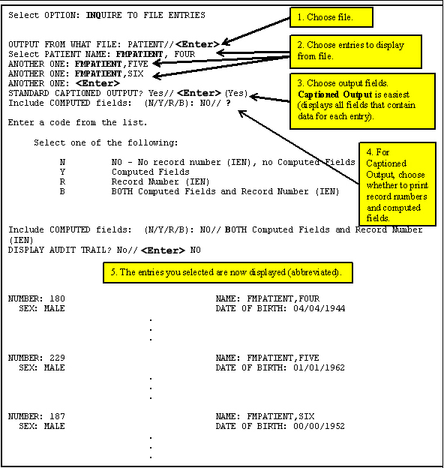
Figure 4: An Example Using the Inquire to File Entries Option

CAPTIONED Output

Choosing CAPTIONED output can be very useful; it prints out all fields (that contain data) for each entry in your report. Use it is a quick way to select all the fields for each entry in your report. Otherwise you need to select each field to print individually, from the list of fields available to print in the file. Answering YES to use CAPTIONED output is the fastest way to choose what fields to print.

The "Include COMPUTED Fields:" Prompt

When using CAPTIONED output, you can choose whether to include COMPUTED fields, record numbers, both, or neither. The default is to display neither. Enter two question marks for detailed Help about responding to this prompt.

The "DISPLAY AUDIT TRAIL?" Prompt

If one or more of the fields have been audited, you will see this additional question. If you answer YES, then you will see the changes that have been recorded for the various fields in the AUDIT file (#1.1), along with the current values of the fields.

SORT Templates

When you choose several entries to display, you will be prompted:

STORE THESE ENTRY ID's IN A TEMPLATE:
Figure 5: Being Prompted to Store Entries Into a Template

You can save your list of selected entries in a SORT template by entering a template name at this prompt. Your list of entries is then saved in a SORT template. You can then reuse the list of selected entries in the template when you do additional printing from this file in the future.

For more information on using SORT templates, please refer to the "Saving Sort Criteria (SORT Templates)" topic in Chapter 2, "Print," in this manual.

Choose Your Own Print Fields
(Don't use STANDARD CAPTIONED OUTPUT)

To choose your own fields to output for each entry, answer NO to the "STANDARD CAPTIONED OUTPUT?" prompt. You can then choose your own output fields. For example, if you only need NAME, DATE OF BIRTH, and PROVIDER information about a selected patient, you could request it, as shown in the following example:

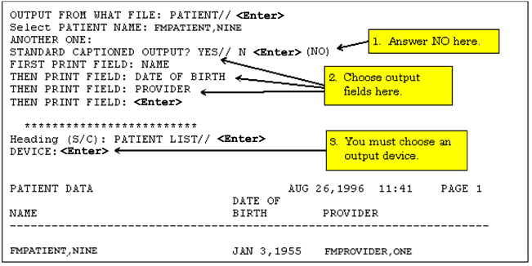
Figure 6: Choosing Your Own Print Fields

For more information on customizing output print fields, please refer to Chapter 2, "Print," in this manual.

It provides detailed information about the different choices you can make at the "PRINT FIELD:" prompt to display your information in different ways.

Choose Your Own Device
(Don't use STANDARD CAPTIONED OUTPUT)

If you enter YES at the "STANDARD CAPTIONED OUTPUT?" prompt, output is sent to the HOME device, which ordinarily is the terminal you are using. To send output to a printer, you need to answer NO at the "STANDARD CAPTIONED OUTPUT?" prompt. This means you must choose your own print fields, as described above. Doing this allows you to select the output device, however.

If you answer NO to the "STANDARD CAPTIONED OUTPUT?" prompt, you can still get CAPTIONED output, however. To do this, choose the CAPTIONED PRINT template at the first "PRINT FIELD:" prompt, as shown below.

Enter a left bracket, "[", and the word CAPTIONED. CAPTIONED OUTPUT from the template works exactly as if you had answered YES at the "STANDARD CAPTIONED OUTPUT?" to request CAPTIONED OUTPUT.

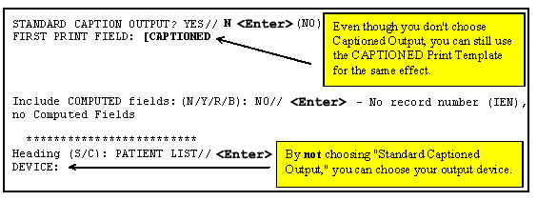
Figure 7: Choosing a Device and Getting STANDARD CAPTIONED OUTPUT

Print

How to Print Reports from Files

With the Inquire to File Entries option, you can select entries from a file, one by one, choose a format for displaying the selected entries, and then output the selected entries.

VA FileMan's print capabilities, on the other hand, allow you to select entries, not one by one, but instead by choosing a range of entries based on the sorting order. You can choose all entries in a file, for example, and sort them in alphabetical order for the printout. Alternatively, you can choose all entries sorting between "E" and "F" and sort them in alphabetical order for the printout.

VA FileMan's Print Capabilities

There are two ways in which you'll have an opportunity to use VA FileMan's print capabilities:
- An option that has been set up already to allow you to print from a particular file.
- VA FileMan's Print File Entries option, which lets you print from any file to which you have access.

In either case, use of VA FileMan's print features is very similar. In most cases, the only difference is that with the Print File Entries option, you have to choose from which file to print.

Unlike the Inquire to File Entries option, which displays individual records, VA FileMan's print can list all records in a file. Thus, the focus of the Inquire to File Entries option is a single or small group of entries while VA FileMan's prints are concerned with the entire file.

VA FileMan's print features allow considerable flexibility in selecting entries, ordering (or sorting) the entries selected, choosing which fields to display, and formatting the output.

The following two basic components can be used to create a report:
1. "SORT BY:" dialogue. Used to sort (and sometimes narrow down) the entries that you want displayed.
2. "PRINT FIELD:" dialogue. Used to choose the fields you want and the format of their display.

The choices you can make at these two prompts are discussed in detail later in this chapter.

Standard Column Format for VA FileMan Prints

VA FileMan has a standard, columnar format for print output. The file name, current date/time, and page number appear at the top of each report page, followed by column headings that correspond to the labels of selected fields. There are many ways to customize the format, as shown below:

PATIENT LIST NOV 28, 1996 11:32 PAGE 1
NAME SEX
---------------------------------------------------------------------
FMPATIENT,SEVEN MALE
FMPATIENT,EIGHT MALE
FMPATIENT,NINE MALE
FMPATIENT,10 FEMALE
Figure 8: An Example of a Standard Printout

This simple example of a report (as seen in Figure 8) is generated by the dialogue that follows. It prints information from all the entries in the PATIENT file, ordered by NAME (the .01 field in the file). Only data from the NAME and SEX fields are printed, as requested at the "PRINT FIELD:" prompts:

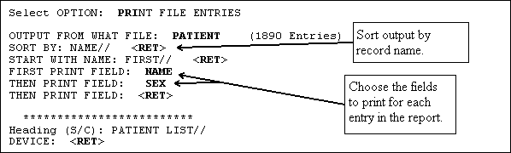
Figure 9: Dialogue Encountered When Creating a Printed Report

You would have received information about every patient in the file, not just these four. You could have asked for several more fields to be printed. They would appear as columns of output, left to right, in the order specified.

Sorting

Specifying SORT BY Fields

Sorting determines the order that records are printed in your reports. You can accept the default order (by the .01 field), or you can specify your own sorting order. The sort can be a simple sort, based on only one field, or you can sort based on the values of several fields.

For example, if you want to print the entries in order from oldest to youngest patient, you could sort the report by date of birth (the DATE OF BIRTH field in the PATIENT file):

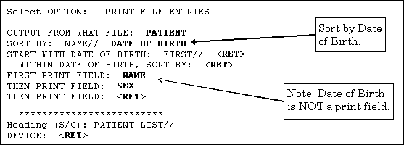
Figure 10: Specifying a Sort Order for a Printed Report

The output then prints in the following order (by DATE OF BIRTH):

PATIENT LIST NOV 28, 1988 11:36 PAGE 1
NAME SEX
-------------------------------------------------------------------------------

DATE OF BIRTH: OCT 14, 1877
FMPATIENT,12 FEMALE
DATE OF BIRTH: NOV 3, 1922
FMPATIENT,13 MALE
DATE OF BIRTH: APR 4, 1933
FMPATIENT,NINE MALE
Figure 11: An Example of a Printed Report in a Specific Order

In the previous example, the sort criterion (DATE OF BIRTH) is printed with every change in sort value. VA FileMan does this when a sort field is not specified as a print field.

To suppress the printing of sort values (subheaders) in the body of your report, you can either:
- Add the field you are sorting by to the print field list.
- Place an at-sign (@) in front of the field label at the "SORT BY:" prompt. In the previous example, you would sort by @DATE OF BIRTH instead of DATE OF BIRTH.

Sorting Order

The ordering of entries within a sort is generally from low value to high value. Some special cases:
- SET OF CODES DATA TYPEs are sorted by the internally stored code, not the value which is output.
- FREE TEXT fields usually sort from lowest value to highest value following the ASCII sorting sequence: Digits sort before uppercase letters, which sort before lowercase letters (e.g., M1 sorts before MC which sorts before Mc).

Sorting Canonic Numbers and Non-Canonic Strings, and the ;TXT Sort Qualifier

Canonic numbers are pure numbers that do not have leading zeros, or trailing zeros after a decimal point. Thus, 1.1 is a canonic number but 01.1 and 1.10 are not. A non-canonic string is everything else. For example, "8C" is a non-canonic string.

This distinction is important when sorting, because in all VA FileMan sorting, canonic numbers sort first, and everything else sorts second. Usually this works very well. But in a few cases where sort fields contain a mix of canonic numbers and non-canonic strings, unexpected sort orders result. Classic cases include sorting on Social Security Numbers and on ward locations.

Consider Social Security Numbers (SSNs). The SSNs 666333333 and 666999900 are canonic numbers. But the SSN 000769000 is not a canonic number, because of its leading zero. When you use the default sort based on Social Security Number, you get output that looks like the following:

PATIENT LIST JUL 19,1996 11:36 PAGE 1
SSN NAME
-------------------------------------------------------------------------------

666333333 FMPATIENT,13
666999900 FMPATIENT,14
000769000 FMPATIENT,15
Figure 12: Sorting Canonic and Non-Canonic Numbers

A similar situation occurs when you sort on ward locations. Suppose you have wards 8, 8C, and 9. 8 and 9 are canonic numbers, while 8C is a non-canonic string. Thus, if you sort on ward location, your output comes out in this order: 8, 9, 8C.

To avoid this problem, use the sort qualifier ";TXT" on your sort field. This forces all field values to be non-canonic, with the result that a group of strings like 8, 8C, and 9 sort in the expected order.

For more information on the ";TXT" sort qualifier, please refer to the list of Sort Qualifiers below.

Sorting to Select Entries for Printing

Besides using sorting to determine the order of entries printed, you can also use the "START WITH ...:" prompt to restrict what entries are printed to a range. For example, if you accept the default sort range (from first to last), you may get a report with every item in the file listed. You can cut this list down to a subset of the entries in the file by how you sort (e.g., entries that sort from FMPATIENT,A to FMPATIENT,Z only).

To specify a sort range, enter the range starting point at the "START WITH...:" prompt, and the range end point at the "GO TO...:" prompt. For example:

SORT BY: NAME// <Enter>
START WITH NAME: FIRST// FMPATIENT,A
GO TO NAME: LAST// FMPATIENT,Z
Figure 13: Specifying a Sort Range

Selecting All Entries with the Same Value for One Field

A simple kind of selecting can be done to choose only those entries that have a particular value for a field. For example, to list only those patients who have a DIAGNOSIS equal to CANCER, you can sort as in the example below:

START WITH DIAGNOSIS: FIRST// CANCER
GO TO DIAGNOSIS: LAST// CANCER
Figure 14: Choosing Entries with a Specific Value

Other Ways of Selecting Entries

The "START WITH ... GO TO .." dialogue can be used to do sophisticated selecting from a file. Computed expressions can be entered at the prompts to filter the entries to be printed.

These powerful techniques are discussed in the "Computed Expressions" chapter of the VA FileMan Advanced User Manual.

You can also use VA FileMan's search functions to select entries for printing.

For more information on VA FileMan's search functions, please refer to Chapter 3, "Search," in this manual.

Including Entries with Null Fields in Your Sort (Start With @)

When you sort a report on a particular field, if any record in the file has no value in that field, that record will be skipped and not printed, if you accept the default sort start value (FIRST). In other words, in a print from the PATIENT file, if you sort on the PROVIDER field, start sorting from the default of FIRST, and there are some patients with nothing in their PROVIDER field, those patients will be left off of the report entirely.

If you want to include records in your report, even if they have no value in the field you are sorting on, sort from "@" instead of accepting the default of FIRST. As in the example below, enter an at-sign (@) at the "START WITH:" prompt:

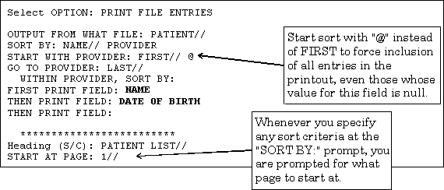
Figure 15: Including Records with Null Values

The output of this sort would then include all records, even those with no value in their PROVIDER fields:

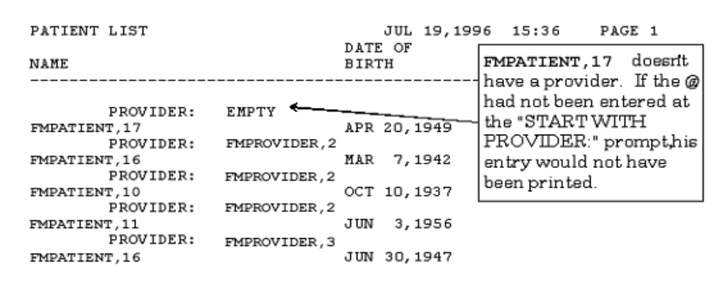
Figure 16: An Example of a Report Displaying Fields with Null Values

Sort Qualifier Reference

As well as entering fields to sort by, you can also enter formatting controls in the "SORT BY:" dialogue. Add these qualifiers to the field label or to the computed expression you're entering at the "SORT BY:" prompt.

Sort Qualifiers to use at "SORT BY:" Prompts

The following table illustrates the sort qualifiers you can use at the "SORT BY:" prompts:

Qualifier | Action | Discussion
!field | Number entries by sort value | Entries having the same value for the SORT BY field are numbered sequentially starting at one.
#field | Page break when sort value changes | Starts a new page every time the value of the sorted field changes.
'field | Specify a range for output without sorting | Lets you select entries based on this field in the "START WITH . . . GO TO . . ." dialogue, but not sort based on the field.  Since sorting requires substantial system resources, do not sort entries unnecessarily.
+field | Subtotal within a SORT BY field | When subtotaling, you indicate in the "PRINT FIELD" dialogue the fields to be enumerated. All requested numeric operations (sum, count, etc.) will be done as a subtotal when the SORT BY field changes in addition to the grand totals at the end.  You can sub-subtotal by adding a prefix of + to two fields in the "SORT BY:" dialogue. For example:  SORT BY: +REGION  WITHIN REGION, SORT BY: +STORE  This produces subtotals for each STORE within the subtotals for each REGION.
Table 2: Sort Qualifiers
Table 2 (continued):

Qualifier | Action | Discussion
-field | Reverse sort order | Only effective for NUMERIC and DATE/TIME valued fields. For DATE/TIME values, prints from most recent to earliest; for NUMERIC values, from largest to smallest.
@field | Suppress the printing of subheader | Normally, a subheader with the value of the SORT BY field name is printed for SORT BY fields, if the field is not also specified as a print field. Using an at-sign (@) suppresses those subheaders.
field;Cn | Set column of subheader | The number (n) indicates the column to begin the subheader.
field;Ln | Use less than the entire sort field for sorting | The ;L suffix lets you specify that only the first "n" characters of the field be used to sort. Thus, if you specify:  SORT BY: NAME;L2  Only the first two letters of the name field will be used for sorting: the order of "Maris,Roger" and "Mantle,Mickey", for example, will be unpredictable in your output.
field;Pa-b | Store sort range for display | The ;P suffix saves the "START WITH" and "GO TO" sort range for one level of sort fields, for later reference at a "PRINT FIELD" prompt. You can substitute any string (up to 60 characters in length) for "a" and "b" in ";Pa-b". Whatever strings you use as "a" and "b" (e.g., FROM and TO) become subscripts of the PARAM() array:  SORT BY: NAME;PFROM-TO  START WITH NAME: FIRST// C  GO TO NAME: LAST// Dzzzzz  (continued on next page)
Table 2: Sort Qualifiers

Table 2 (continued):

Qualifier | Action | Discussion
field;Pa-b | (continued) | Then at a "PRINT FIELD" prompt, you can reference the saved values by using PARAM("a-string") and PARAM("b-string"). Thus, in this case:  THEN PRINT FIELD: PARAM("FROM")  THEN PRINT FIELD: PARAM("TO")  The sort-from and sort-to values of "C" and "Dzzzzz" in the report would then print in the appropriate location. The typical reason to save sort values, and then retrieve them from the PARAM array in a print field, is for custom report headers (which are created as PRINT templates). It is one method to print sort criteria in the report header.  If you need to sort on two or more fields, you need to use a different string for "a" and "b" at each level, or else the values will overwrite each other.  No value is saved in the PARAM array if the user accepts "FIRST" or "LAST" as the "START WITH" or "GO TO" sort values; the PARAM array will be null.
field;Sn | Skip lines when sort value changes | The ;S suffix skips one line between sort field values, if no number is added. If you specify a number (n), n-lines are skipped. You can use this qualifier to skip lines after subtotals are printed by inserting the following after the last subtotaled field:  WITHIN X, SORT BY: @"";S  START WITH "": FIRST// @  GO TO "": LAST// @
field;TXT | Sort numbers as text | The ;TXT sort qualifier forces digits to be sorted as alphanumeric strings, not as numbers (22 sorts before 3). Use this to correctly sort mixed canonic and non-canonic numbers.
Table 2: Sort Qualifiers

Table 2 (continued):

Qualifier | Action | Discussion
field;"xxx" | Replace caption in subheader and sort dialogue | The default subheader is the field label or expression entered at the "SORT BY:" prompt. The same string is used within the sort dialogue. You can substitute a string of your choosing by adding a semicolon (;) and text enclosed in quotation marks. For example:  SORT BY: DATE OF BIRTH;"Birthdate: "  To suppress the caption in the subheader, enter two double quotes after the semicolon:  SORT BY: DATE OF BIRTH;""  The specified caption is also used in the subsequent sort dialogue. This is useful in simplifying the sort dialogue when a field label is confusing, is concatenated, or is an extended pointer. For example:  SORT BY: STORE:REGION;"Location:"  START WITH Location: FIRST// <Enter>  WITHIN Location, SORT BY: <Enter>  PRINT FIELD: STORE  THEN PRINT FIELD:  "Location:" is substituted for "STORE:REGION".
Table 2: Sort Qualifiers

Saving Sort Criteria (SORT Templates)

You can save your sort criteria in a SORT template. This lets you reuse the same sorting instructions in future prints from the current file. PRINT templates are stored in the SORT TEMPLATE file (#.401). If you sort by more than three fields, you are asked whether you want to store your sort criteria in a SORT template:

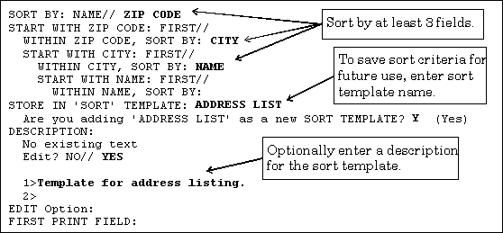
Figure 17: Creating a SORT Template

Forcing Creation of a SORT Template

Ordinarily, you are only asked whether to save your sort criteria in a SORT template if you enter three or more fields at the "SORT BY:" prompts. However, to force this question to be asked, enter a right bracket (]) by itself at one "SORT BY:" prompt. No matter how few fields you sort by, you'll still be prompted to save your sort criteria in a SORT template.

SORT BY: NAME// ]
SORT BY: NAME//
Figure 18: Forcing the Creation of a SORT Template

Reusing Sort Criteria in New Reports

The reason to save sort criteria in a SORT template is so that you can reuse your sort criteria in a new report from the same file.

To reuse a SORT template as the sort criteria in a new report, at the "SORT BY:" prompt in the new report, enter a left bracket ([) plus the template name:

OUTPUT FROM WHAT FILE: NEW PERSON// <Enter>
SORT BY: NAME// [ADDRESS LIST <Enter>
(Dec 08, 1995@07:53) User #34 File #200
WANT TO EDIT 'ADDRESS LIST' TEMPLATE? NO// <Enter>
FIRST PRINT FIELD:
Figure 19: Reusing a SORT Template

Choosing Print Fields

Specifying Fields to Print

After you have specified the order in which the output should occur, you are asked to list the fields you want displayed for each file entry. In the simplest case, fields are identified by their label. If you enter a single question mark (?) at the prompt, a list of all the fields in the file is displayed. If you enter the name of a multiple, you are asked for the subfields you want printed. A subfield must be specified even if the multiple has only one subfield.

To print all fields in the file, enter ALL (uppercase) at the "FIRST PRINT FIELD:" prompt. You are then prompted:

Do you mean ALL the fields in the file? NO//
Figure 20: Confirmation Message to Print All Fields

Enter YES to indicate all fields. Otherwise, the file is searched for field labels beginning with the letters "ALL".

Fields from other files can also be printed using extended pointers. This technique is described in the "Using Computed Expressions in COMPUTED Fields" topic in the "Computed Expressions" chapter of the VA FileMan Advanced User Manual. You can also enter other computed expressions, which are also described in that chapter.

Print Qualifier Reference

VA FileMan's print capabilities provide many ways to format a report. If you don't specify any formatting controls, a format is constructed automatically. The width of each field's print area is computed using information from the field's definition. The default width is the larger of the maximum number of characters allowed for the field and the length of the longest word of the field's label (or other specification) in the print dialogue. Two inter-column spaces are added to separate fields.

However, by using print qualifiers at the "PRINT FIELD:" prompt, for each field, you can indicate how long the field's print area should be, where it should start, how many lines to skip before printing the field, and the column title for the field. You can also insert literal strings within the output.

For fields that have numeric values, you can call for several arithmetic calculations and indicate the number of decimal digits of accuracy. If you have requested subtotals in the sort dialogue (by preceding the field with a "+"), calculations are done at the subtotal level as well.

Print Qualifiers to use at "PRINT FIELD:" Prompts

The following table illustrates the print qualifiers you can use at the "PRINT FIELD:" prompts:

Qualifier | Action | Discussion
!field | Count | The number of entries with non-null values in this field are counted.
#field | All statistics | Use with NUMERIC fields only. Six lines of statistical output are generated for the selected field: Total, count, mean, maximum, minimum, and standard deviation.
&field | Total | Use for NUMERIC fields only. The values of all occurrences of this field are summed.
+field | Total, count and mean | Use for NUMERIC fields only. The sum, count of non-null values, and the arithmetic mean of the non-null values are printed.
field;Cn | Set start column position | You can specify the starting column of a field's display. If the number (n) is a positive number, the field prints in that column counting from the left margin. If it is negative, the field starts in that column as subtracted from the right margin. If there is not enough room on a line for the field to display properly, it is moved to the line below. Adding ;C1 always starts a field's display at the beginning of a line.
field;Dn | Round decimal fractions | Specify the number of decimal digits of accuracy with a number, "n". If n=0, the number is rounded to a whole number. The number (n) must be > 0 or = 0.
Table 3: Print Qualifiers

Table 3 (continued):

Qualifier | Action | Discussion
field;Ln | Left justify and truncate | To left justify within a field width of "n" characters, follow the ;L with the number of column positions you want the field to occupy. If necessary, the data is truncated to fit into this length. Since non-numeric fields are left justified by default, the only effect of ;L on those fields is truncation. This qualifier does not affect DATE/TIME-valued fields.
field;N | Suppress consecutive duplicate values | If you do not want the same value for a field printed on consecutive rows of a report, add ;N to the field specification.
field;Rn | Right justify text | To right justify within a field of "n" characters, follow the ;R with that number. Right-justified data is not truncated; if "n" is not large enough, data spills into the next field's area causing confusing output. NUMERIC DATA TYPE fields are right justified by default. However, computed expressions with numeric results are not right justified automatically.
field;Sn | Skip lines between fields | You can indicate a number of lines to skip before printing a field by using ;Sn. Without a number, ;S skips a single line. If your field has a null value, "n" lines are skipped anyway. You cannot use ;S with a WORD-PROCESSING-type field. To skip one line before a WORD-PROCESSING field, precede the field with an additional print specification like this:  THEN PRINT FIELD: "";S
field;T | Use field TITLE as header | If you want to use the field's TITLE, as defined in the data dictionary, instead of its LABEL in the header, add ;T.
Table 3 Print Qualifiers

Table 3 (continued):

Qualifier | Action | Discussion
field;Wn | Wrap text | The ;W suffix splits a field that is too long for its field column width at word boundaries (spaces) and prints it out fully on two or more rows. You can optionally follow the ;W with the number of column positions to be occupied by each line of output. If the field's data dictionary definition says to always print in word-wrap mode, WORD-PROCESSING DATA TYPEs are automatically wrapped. The ;W suffix overrides the ;R or ;L suffixes; do not use them together.
field;X | Suppress header and inter-column spaces | Follow the field specification with ;X to suppress the two spaces normally inserted before a field and the column header for the field. The result is concatenation of the field with the field that came before it. The ;X suffix is often used to add a literal caption to a field.
field;"xxx" | Customize header | The default header for columns of a report is the field label (for fields) or a computed expression (for "on the fly" computed expressions). To change the header, follow the field label with a semicolon (;) and the column header you want. Enclose the header in quotes. When possible, spaces wrap the substitute header within a print width obtained from the field's data definition. For example:  THEN PRINT FIELD: DOB;"Date of Birth"  THEN PRINT FIELD: DOB;"Date_of_Birth"  The first specification prints the header on two lines; the second prints it on one line (with underscores). To suppress the header, add ;"" to the field.
Table 3 Print Qualifiers

Table 3 (continued):

Qualifier | Action | Discussion
field;Yn | Set start row position | You can start printing a field on any line on the page. If "n" is positive, the field is printed on that line as counted from the top of the page. If it is negative, it is printed on that line as counted from the bottom. When specifying ;Yn, you must account for any page header that is displayed.
"xxx" | Insert a literal | At the "PRINT FIELD:" prompt enclose a free text literal in quotes. The literal is inserted into the body of the report. For example, the following specifications begin each entry's display with a caption and NAME:  FIRST PRINT FIELD: "Patient's name:"  THEN PRINT FIELD: NAME;""  OR  FIRST PRINT FIELD: "Patient's name:"  THEN PRINT FIELD: NAME;X  The header for the NAME field is suppressed in both examples.
Table 3 Print Qualifiers

You can string together several of these print qualifiers at the "PRINT FIELD:" prompt. For example:

THEN PRINT FIELD: +WEIGHT;S1;C3;L6;"Patient Weight"
Figure 21: Stringing Several Print Qualifiers Together

These specifications translate to: total, count, and give the mean for all values of the WEIGHT field, which must be a NUMERIC valued field. Skip one line before printing the values. Start the output in column three, left justify and truncate it to six character positions, and print the column heading "Patient Weight" on two lines.

Saving Print Criteria (PRINT Templates)

PRINT templates let you store your print field specifications for use at a later time. You can retrieve the template at a later time by using the template name surrounded by square brackets. Template names must be unique with respect to any other PRINT template created for the same file. VA FileMan will notify you, if you try to create a template with a template name that already exists for a file. PRINT templates are stored in the PRINT TEMPLATE file (#.4).

To see a list of all existing templates that pertain to the file you are dealing with, enter a left bracket and a question mark ([?) at the prompt where you can retrieve templates. For example:

FIRST PRINT FIELD: [?
Figure 22: Obtaining a List of All PRINT Templates for a File

This gives you a list of the PRINT templates available for your use with the file.

You are automatically prompted for a template name when it is determined that a considerable amount of information has been specified. If you choose five or more print fields, or if some of your print fields have special formatting specifications, you are prompted to store your print field specification in a PRINT template, as follows:

STORE PRINT LOGIC IN TEMPLATE:
Figure 23: Creating a PRINT Template

If you do not want to store your specifications in a template, simply press the Enter/Return key. If you do want to save these print specifications for future reuse, however, respond to this prompt with the name of a template (either new or existing). Do not enclose the name in brackets; use brackets only to invoke a template, not to name one.

Forcing Creation of a PRINT Template

Ordinarily, you are only asked whether you want to save your PRINT template if you enter five or more fields at the "PRINT FIELD:" prompt, or enter complex print specifications. However, by entering a right bracket (]) by itself at one of your field prompts, you can force the prompt that asks you for a template name, no matter how few fields you specify. You must designate at least one field to be printed to receive the template prompt, though.

For example:

PRINT FIELD: ] <Enter>
PRINT FIELD: NAME
THEN PRINT FIELD: <Enter>
HEADING: <Enter>
STORE PRINT LOGIC IN TEMPLATE: ID PRINT
Figure 24: Forcing the Creation of a PRINT Template

Using and Editing PRINT Templates

If a PRINT template has already been defined for a file, you can answer the "FIRST PRINT FIELD:" prompt with the template name, enclosed within brackets. For example:

FIRST PRINT FIELD: [PATIENT DATA]
WANT TO EDIT 'PATIENT DATA' TEMPLATE? NO// Y <Enter> (YES)
NAME: PATIENT DATA// <Enter>
READ ACCESS: <Enter>
WRITE ACCESS: <Enter>
Figure 25: Reusing a PRINT Template

After you retrieve a template, you are asked if you want to edit the template. If you answer YES (as shown above), you are allowed to edit the template name. To delete the template, enter an at-sign (@). After the "NAME:" prompt, you can edit the template security codes for READ ACCESS and WRITE ACCESS.

Next, you are prompted to edit each "PRINT FIELD:" value, containing each print field stored in the template. You can leave each print field as is, edit it, or delete it with the at-sign character (@).

To insert a new print field ahead of the print field being displayed in your template, precede the print field you want to insert with a caret ("^"). See the following example of adding to a PRINT template (INPUT and SORT templates have this feature also):

FIRST PRINT FIELD: FIELD1// <Enter>
THEN PRINT FIELD: FIELD2// <Enter>
THEN PRINT FIELD: FIELD4// ^FIELD3
THEN PRINT FIELD: FIELD4// <Enter>
Figure 26: Inserting a New Print Field

To insert a Multiple field and its subfields ahead of the field currently displayed in the template, do the following:
1. Enter a caret ("^") followed by the name of the Multiple field.
2. Ignore the default presented at the "THEN PRINT FIELD:" prompt and insert each subfield by entering a caret ("^") followed by the name of that subfield.
3. After all subfields have been added, enter a caret ("^") and a right bracket (^]).

For example:

FIRST PRINT FIELD: FIELD1// <Enter>
THEN PRINT FIELD: FIELD2// <Enter>
THEN PRINT FIELD: FIELD3// ^MultField <Enter> (multiple)
THEN PRINT MultField SUB-FIELD: FIELD3// ^SubField1
THEN PRINT MultField SUB-FIELD: FIELD3// ^SubField2
THEN PRINT MultField SUB-FIELD: FIELD3// ^]
THEN PRINT FIELD: FIELD3//
Figure 27: Inserting a Multiple Print Field

The CAPTIONED PRINT Template: [CAPTIONED

Every file has a pre-defined CAPTIONED PRINT template that you can select at the "PRINT FIELD:" prompt. The CAPTIONED PRINT Template can be very useful; it prints out all fields for each entry in your report. Use it is a quick way to get all the fields for each entry in your report (much quicker than entering each field individually)!

Use it as follows:

FIRST PRINT FIELD: [CAPTIONED
Figure 28: Choosing a CAPTIONED PRINT Template

COMPUTED Fields and Record Numbers in CAPTIONED OUTPUT

When you choose the CAPTIONED PRINT Template, you're prompted with "Include COMPUTED fields". At this prompt, you can decide whether to include COMPUTED-type fields in the output for each record, as well as record numbers.

For more information on COMPUTED fields, please refer to the "COMPUTED DATA TYPE" topic in the VA FileMan Advanced User Manual.

FIRST PRINT FIELD: [CAPTIONED

Include COMPUTED fields: (N/Y/R/B): NO// ?

Enter a code from the list.
Select one of the following:

N NO - No record number (IEN), no Computed Fields
Y Computed Fields
R Record Number (IEN)
B BOTH Computed Fields and Record Number (IEN)

Include COMPUTED fields: (N/Y/R/B): NO// BOTH <Enter> Computed Fields and Record Number (IEN)

*************************
Heading (S/C): NEW PERSON LIST//
DEVICE:
Figure 29: Dialogue Encountered When Creating a CAPTIONED PRINT Report

Printing Statistics Only (Totals, Counts, etc.)

If you precede all of the fields that you choose for printing at the "PRINT FIELD:" prompts with a +, &, !, or #, the individual field values are not printed in your report. Instead, you only get the requested statistics, which (depending on the print qualifiers and fields used) can be the total, count, mean, maximum, minimum, and/or standard deviation.

For more information about print qualifiers, please refer to the "Print Qualifier Reference" topic above.

Other Print Features
- Multiple Copies of a Print
- Report Headings
- Suppressing Report Headings (and Page Feeds)
- Custom Headings and Footers
- Printing Sort Criteria in Header or Footer

Multiple Copies of a Print

To generate more than one copy of a report, you must have an output device on your system (such as a spool device or a sequential disk processor [SDP]) which stores data in a linear format. If you choose to send the output to such a device at the "DEVICE:" prompt, the system prompts you as follows:

ENTER NUMBER OF COPIES: 4
OUTPUT COPIES TO DEVICE: PRINTER
Figure 30: Generating Multiple Copies of a Report

In this example, you are asking to print four copies to the device called PRINTER.

You must be using VA FileMan with Kernel or with a device handler similar to Kernel's to produce multiple copies. If you exceed the maximum spool lines allowed you as defined in the KERNEL SYSTEM PARAMETERS file (#8989.3), your report will be stopped.

Report Headings

The heading in a report is what is printed at the top of each report page. Ordinarily, there is a heading (report title), date of report, time of report, page number, and column headers (field titles for fields in the output), as shown below:

PATIENT LIST JUL 19,1996 14:49 PAGE 1
SSN NAME
-------------------------------------------------------------------
Figure 31: An Example of Report Headings

You can customize the report heading when you print. If you ask for Help at the "Heading (S/C):..." prompt, VA FileMan displays the following instructions:

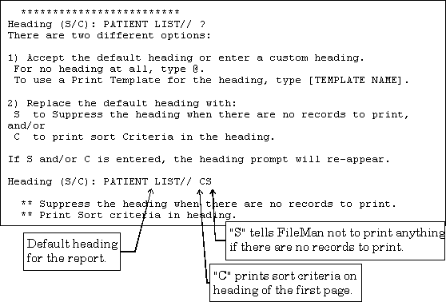
Figure 32: Customizing Report Headings

Thus, at the "Heading (S/C):" prompt, you can:
- Enter "S" to not print the heading (i.e., not print anything), if no records are found to print.
- Enter "C" to print sort criteria in the report heading on the first page.
- Enter a new heading to replace the default heading or press the Enter/Return key to accept the default heading.

Suppressing Report Headings (and Page Feeds)

If you do not want headings to be printed in your output, enter an at-sign (@) at the "HEADING:" prompt:

HEADING: PATIENT LIST// @
Figure 33: Suppressing Headings on a Report

If you want neither headings nor page feeds in your output, enter two at-signs (@@) at the "HEADING:" prompt.

If you suppress the headings in your output and also save your print criteria in a PRINT template, you will be asked:

DO YOU ALWAYS WANT TO SUPPRESS SUBHEADERS WHEN PRINTING TEMPLATE?
Figure 34: Confirming the Suppression of Headings in a PRINT Template

Subheaders are the names of SORT BY fields you see in the body of your report, when you don't include those SORT BY fields as print fields. To automatically suppress all subheaders, answer YES at this prompt.

When you are sorting, you can suppress subheaders individually at each sort level by entering an at-sign (@) in front of the field on which you are sorting. For more information, please refer to the "Sorting" topic above.

Custom Headings and Footers

You can print complex, multi-line headings by using a PRINT template to hold your heading format. Suppose, for example, that you want the patient's name and date of birth to appear as the heading at every page break. You could first create a PATIENT HEADER template as follows:

SORT BY: NAME
START WITH NAME: FIRST// <Enter>
FIRST PRINT FIELD: "PATIENT NAME: "
THEN PRINT FIELD: NAME
THEN PRINT FIELD: "DATE OF BIRTH: ";C50
THEN PRINT FIELD: DATE OF BIRTH
THEN PRINT FIELD: <Enter>
*************************
Heading (S/C): PATIENT LIST// <Enter>
STORE PRINT LOGIC IN TEMPLATE: PATIENT HEADER
Are you adding 'PATIENT HEADER' as a new PRINT TEMPLATE? No// YES <Enter> (Yes)
DEVICE:
Figure 35: Creating a PRINT Template with a Custom Header

Then, at a later time, when you do another print, at the heading prompt, enter the template name:

Heading (S/C): PATIENT LIST// [PATIENT HEADER]
Figure 36: Selecting an Existing PRINT Template with a Custom Header
When you enter a PRINT template name such as PATIENT HEADER at the "Heading (S/C):..." prompt, the format of the template is used as a replacement for the full normal report heading on each page of your report (it replaces the full default heading, including title, time, date, page number, field names, and separator line). Thus, the header, as defined above, would contain no column headings and would not be separated from the body of the report by a horizontal line or even a blank line. You can add these in yourself as print fields in the template, if you so desire.

Custom Footers

You can also add footers to the bottom of each page of a report. First, save the contents of the footer in a template as you do to create a custom heading. Then, use the template at the "HEADING:" prompt with a dash (-) before the first bracket:

Heading (S/C): PATIENT LIST// -[PATIENT FOOTER]
Figure 37: Including a Custom Footer in a PRINT Template

You can specify both a heading and a footer like this:

Heading (S/C): PATIENT LIST// [PATIENT HEADER]-[PATIENT FOOTER]
Figure 38: Including a Custom Header and Footer in a PRINT Template

Specifying only a footer at the "Heading (S/C):" prompt suppresses the default heading. If you need a header as well as footer, you must use custom templates for both.

Printing Sort Criteria in the Heading or the Footer

You can print the sort criteria (values used to sort the report) in the header in two different ways:
- At the "Heading (S/C):" prompt, entering "C" prints the sort criteria in the automatically generated report heading.
- Use the sort qualifier ;Pa-b to save the FROM and TO values used to sort a report. Then, in a customized header or footer (stored in SORT templates), you can retrieve the sort values with PARAM(a-string).
For more information, please refer to the description of the ;Pa-b sort qualifier above.

Search

When you print reports, you can print a subset of the total number of file entries, if you sort your output. For example, by sorting on a file's DATE field, you could sort for entries from October 1st to October 15th, and only print entries whose DATE field falls in that sort range.

Selecting a subset of entries by sorting works well if the subset of entries you would like to print can be isolated based on a contiguous sort range. However, what if you would like a different set of entries (e.g., only entries whose DATE field is equal to either September 1st, October 1st, or November 1st)? You cannot do this with a sort range, because the sort range that includes September 1st and November 1st would include every entry between the two dates.

When you use VA FileMan's search capabilities, you have much more control over what entries you select from a file for printing.

How to Search

As with VA FileMan's print capabilities, there are two methods in which you can use VA FileMan's search features:
- An option that has been set up already to allow you to search a particular file.
- VA FileMan's Search File Entries option, which lets you perform a search on any file to which you have access.

In either case, use of VA FileMan's search features is very similar. In most cases, the only difference is that with the Search File Entries option, you have to choose which file to search.

The steps in searching are:

1. Enter the search conditions (truth tests) to perform on each entry.

2. Specify how the search conditions should be combined (link them together with logical ANDs & ORs) to select records.

3. Format your output (i.e., choose the sort order and print fields).

Search Steps

1. Enter Conditions

First, you must enter one or more search conditions to test each entry. For each condition you choose a field in the entry and a condition to compare the field against.

For example, you could check if an entry's DATE field is NULL, GREATER THAN 10/1/96, or EQUALS 10/1/96.

Search Condition Tests

The following table lists the six possible search conditions against which you can test entries. It also includes the symbol that represents the condition (if any), for what field types the condition can be used, and the description/arguments of each condition:

Condition | Symbol | For Field Types | Description/Arguments
NULL | (none) | All except WORD-PROCESSING. | NULL returns true if the field in question is empty (null). No argument is required.
CONTAINS | [ | NUMERIC, FREE TEXT, WORD-PROCESSING, MUMPS, SET OF CODES, and COMPUTED fields. | Enter a character string that should be contained in matching entry fields.
MATCHES | (none) | NUMERIC, FREE TEXT, MUMPS, COMPUTED, and DATE/TIME fields. | Enter a MUMPS pattern match. The pattern must be valid for the MUMPS pattern match operator.
LESS THAN | < | NUMERIC, COMPUTED, SET OF CODES, FREE TEXT, and DATE/TIME fields. | Enter a value that a matching entry field should be less than. Non-NUMERIC fields are evaluated as if they were numbers. Thus, strings beginning with alpha characters are evaluated as zero.
Table 4: Search Condition Tests

Table 4 (continued):

Condition | Symbol | For Field Types | Description/Arguments
EQUALS | = | All data except WORD-PROCESSING. | Enter a value to which a matching entry field should be equal.
GREATER THAN | > | NUMERIC, COMPUTED, SET OF CODES, FREE TEXT, and DATE/TIME fields. | Enter a value to which a matching entry field should be less than. Non-NUMERIC fields are evaluated as if they were numbers. Thus, strings beginning with alpha characters are evaluated as zero.
Table 4: Search Condition Tests

When you start your search, VA FileMan asks you to enter a field, a condition, and a value to which the field is compared.

For example, to create a search condition that would find all entries whose DATE ACCESS CODE LAST CHANGED field contains a date older than 120 days in the past, you would enter the following:

-A- SEARCH FOR FIELD: DATE ACCESS CODE LAST CHANGED
-A- CONDITION: LESS THAN
-A- GREATER THAN: T-120 <Enter> (Jun 20, 1995)
Figure 39: An Example of a Search Condition

Each prompt above begins with "-A-"; what you've entered becomes search condition "A."

Once you enter your first search condition, you can enter additional search conditions, if you wish. VA FileMan assigns the letter "A" to the first search condition, "B" to the second search condition (if any), "C" to the third, and so on.

Here is an example of entering two truth tests:

-A- SEARCH FOR FIELD: DATE ACCESS CODE LAST CHANGED
-A- CONDITION: LESS THAN
-A- GREATER THAN: T-120 <Enter> (Jun 20, 1995)

-B- SEARCH FOR FIELD: ACCESS CODE
-B- CONDITION: 'NULL

-C- SEARCH FOR FIELD: <Enter>
Figure 40: An Example of Two Truth Tests

2. Combine Conditions

After defining a series of conditions (A, B, etc.), you combine the conditions to yield the complete test that an entry must satisfy to be selected in the search. The complete test is a logical combination of tests A, B, etc., using AND, OR, and NOT.

Operators for Combining Search Conditions

The following table lists the possible operators to combine search conditions:

Condition | Symbol | Description | Example
AND | & | For truth test to be true, the conditions on both sides of the AND operator must be true. The "&" symbol can be omitted (i.e., AB is the same as A&B). | A&B
NOT | ' or - | For truth test to be true, the condition following NOT (i.e., single quote, "'" or dash "-") must be false. If A is false, 'A evaluates to true. | 'A
OR | Enter on new line. | For truth test to be true, only one of the conditions that are combined with OR needs to be true. If A is true and B is false, A OR B evaluates to true. | IF: A <Enter>  OR: B <Enter>
Table 5: Search Condition Operators

For example, if you just want to find all entries for which search condition A is true, you would enter:

-B- SEARCH FOR FIELD: <Enter>
IF: A
OR: <Enter>
Figure 41: An Example of a Single Search Condition Using a Truth Test

A more complicated search might have a number of search conditions (e.g., A, B, C, and D). Thus, for example, to find all entries which either: 1) satisfy both truth tests A and B, or 2) do not satisfy truth test C, but satisfy truth test D, you could combine search conditions as follows:

-E- SEARCH FOR FIELD: <Enter>
IF: A&B
OR: 'C&D
OR: <Enter>
Figure 42: An Example of a Multiple Search Condition Using Truth Tests

In the example above, the logic says "if A and B, or if not C (but D)".

3. Format Output

The remaining steps to finish your search are to choose your sorting criteria (same as with printing) and to choose the fields to print for each matched entry (also the same as with the printing).

A complete search (entering search conditions, combining search conditions, and finishing the search) is shown below:

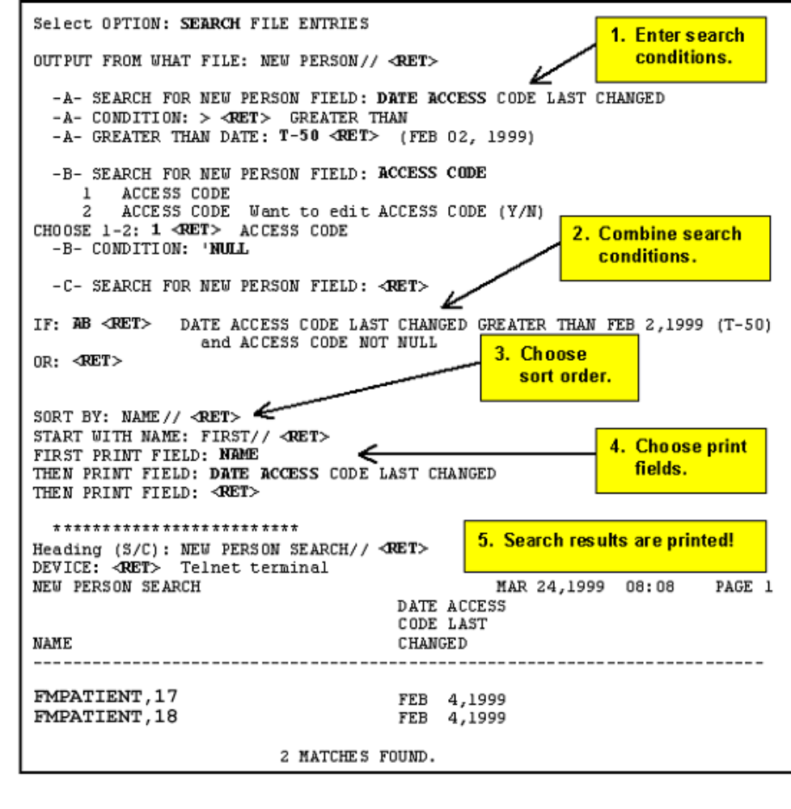Figure 43: An Example of a Completed Search

The previous search (Figure 43) found two entries that matched the search conditions (i.e., DATE ACCESS CODE LAST CHANGED greater than 2/2/99 and ACCESS CODE not null).

Details and Features

Sorting and Searching

As you may recall from Chapter 2, "Print," you can print a subset of entries from a file by sorting (i.e., printing only those entries that fall between a sort-from value and a sort-to value). Searches also select a subset of entries from a file, although with more flexibility than with sorting.

When you print your output from a search, you are also given a chance to sort the output. This means that while searching selects a subset of entries to print, through sorting you can further restrict that subset of entries that is going to print. How does sorting affect the output of the searches?

The answer is that VA FileMan uses both your search and sort order to select entries. You enter the search criteria before you enter the sort order. However, the selection of entries indicated in the sort ("START WITH … GO TO" dialogue) sorting is done first, after which the search conditions are applied to all remaining entries to determine the final set of matching entries.

SEARCH Templates

You can save the results of your search in a SEARCH template. Doing this allows you to:
- Reuse your search criteria to perform another search.
- Reuse your search results (the list of entries selected as a result of both the search and the sort order).

This is because SEARCH templates store both your search criteria and also the list of entries that is found in your search. SEARCH templates are stored in the SORT TEMPLATE file (#.401).

Creating SEARCH Templates

The place to save your search criteria and results in a SEARCH template is right after you specify your search conditions. At this point, you are prompted:

STORE RESULTS OF SEARCH IN TEMPLATE:
Figure 44: Creating a SEARCH Template

You can create a template at this prompt. Because SEARCH templates are stored in the same file as SORT templates (the SORT TEMPLATE file, #.401), you can't give a SEARCH template the same name as a SORT template. To avoid creating a SEARCH template, just press the Enter/Return key at this prompt. Usually, only the creator of a SEARCH template can use it.

Reusing Search Criteria Stored in a SEARCH Template

Whenever you do a search, you can reuse the search criteria (i.e., your combined search conditions) stored in a SEARCH template. To do this, enter the bracketed SEARCH template name at the first "SEARCH FOR FIELD:" prompt:

-A- SEARCH FOR FIELD: [RESEARCH 1]
Figure 45: Reusing a SEARCH Template at the "SEARCH FOR FIELD" Prompt

A new search will be performed with the recalled search criteria.

Reusing Search Results in Another Search

Whenever you do a search, you can recall the results of a previous search (the list of entries found in the search) at the "SORT BY:" prompt. In this case, the new search is done against the entries in the SEARCH template, rather than the entire file. Answer the "SORT BY:" prompt with the bracketed SEARCH template name:

SORT BY: NAME// [RESEARCH 1]
Figure 46: Reusing a SEARCH Template at the "SORT BY" Prompt

Reusing Search Results in a Print

When doing VA FileMan prints, you can also recall the results of a previous search at the "SORT BY:" prompt. In this case, the entries saved in the SEARCH template are the ones printed in the report. This is handy if you do a search, collect a group of entries, and then want to print several different reports based on the same set of entries.

Internal vs. External Field Values for Search Conditions
- For all SET OF CODES field types, you must use external values for the search conditions.
- For DATE/TIME field types, you can enter internal or external values for the search conditions.
- For other DATA TYPEs (NUMERIC, COMPUTED, and FREE TEXT), there is no difference between internal and external value.
- For POINTER TO A FILE or VARIABLE-POINTER fields, the sort is based on the field type of the .01 field of the pointed-to file.

Print Number of Matches Found

If you only want to print the number of matches found, without printing any of the matched entries, answer the "FIRST PRINT FIELD:" prompt by simply pressing the Enter/Return key.

Searching Multiples

Searching on multiple-valued fields, like the DIAGNOSIS field in the PATIENT file, is a special situation. You must specify whether a truth test is to be considered met if at least one of the subentries for an entry passes the test or if all the subentries must pass the test.

When truth tests contain a negative (contains a single quote "'"), you can even specify that an entry with no subentries should automatically pass the test.

Suppose, for example, that you want to search for all patients who were born before 1900 and who don't have a DIAGNOSIS containing the word ANGINA:

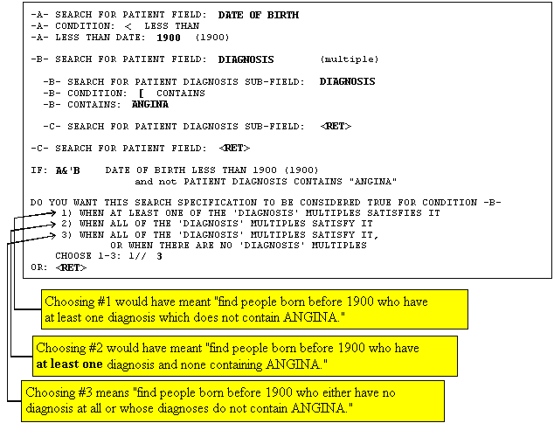
Figure 47: An Example of a Search on a Multiple Field

Another ambiguity about searches of multiple fields is how to interpret two separate truth tests on the same subfield.

For example, if you are searching for DIAGNOSIS containing ANGINA and also for DIAGNOSIS containing PECTORIS, do you want to find:
- Only those patients who have ANGINA and PECTORIS in the same diagnosis name?
- Patients who might have one diagnosis containing ANGINA and a different diagnosis containing PECTORIS?

Whenever you combine two truth tests (e.g., A and B) pertaining to the same multiple-valued field, you are prompted:

CONDITION -A- WILL APPLY TO THE SAME MULTIPLE AS CONDITION -B-
OK? YES//
Figure 48: Search Prompts Encountered when Searching on a Multiple Field

In our example (Figure 47 and Figure 48), a YES answer means that ANGINA and PECTORIS must be found in the same DIAGNOSIS. If you answer NO, you can specify how A and B will apply:

DO YOU WANT THIS SEARCH SPECIFICATION TO BE CONSIDERED TRUE FOR CONDITION -A-

1) WHEN AT LEAST ONE OF THE 'DIAGNOSIS' MULTIPLES SATISFIES IT

2) WHEN ALL OF THE 'DIAGNOSIS' MULTIPLES SATISFY IT

CHOOSE 1-2: 1// 2

DO YOU WANT THIS SEARCH SPECIFICATION TO BE CONSIDERED TRUE FOR CONDITION -B-

1) WHEN AT LEAST ONE OF THE 'DIAGNOSIS' MULTIPLES SATISFIES IT

2) WHEN ALL OF THE 'DIAGNOSIS' MULTIPLES SATISFY IT

CHOOSE 1-2: 1// <Enter>
Figure 49: Additional Search Prompts Encountered when Searching on a Multiple Field

In this case, all the diagnoses would need to satisfy the A condition, but only one (or more) would need to satisfy the B condition.

Applying search tests to fields in a multiple selects entries at the top level of the file. VA FileMan's searching features cannot be used to select specific subentries.

The Browser

If your site is using Kernel, your site manager may have set up an output device called BROWSER. If so, you can view any report on the screen instead of on paper. Do this by printing your report to the BROWSER device instead of the HOME device or a printer.

The Browser makes it very easy to view reports on screen. Its main features are:
- Scroll forwards and backwards through a report. This means you don't lose reports "off the top" of the screen, like you do when you print to the HOME device.
- Use the Search feature to find and immediately jump to any text in a report.
- Copy text from the report to the VA FileMan Clipboard; later, if you're editing a mail message or other WORD-PROCESSING-type field with the Screen Editor, you can paste from the clipboard.
For more information on the Screen Editor, please refer to Chapter 10, "Screen Editor," in this manual.

As you become accustomed to using the BROWSER device, you may find that you start to save paper by viewing reports that otherwise you would end up printing.
There is also a Browser option that lets you browse the contents of any WORD-PROCESSING-type field to which you have access.

The Browser Screen

The following figure illustrates the Browser screen:

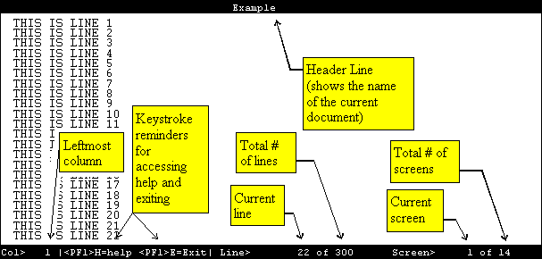
Figure 50: An Example of the Browser Screen

Browser Features

The following Browser features are described below:
- Navigation Keystrokes
- Clipboard
- Search
- Online Help
- Other Features
- The Browser as an Option

Cursor Movement (Navigation Keystrokes)

The following table illustrates the keystrokes you use to navigate while in the Browser:

To | Press
Scroll up or down one line at a time | <ArrowUp> and <ArrowDown>
Scroll right 22 columns | <ArrowRight>
Scroll to rightmost edge | <PF1><ArrowRight>
Scroll left 22 columns | <ArrowLeft>
Scroll to leftmost edge | <PF1><ArrowLeft>
Page Down | <PF1><ArrowDown>, <NextScreen>, or <PageDown>
Page Up | <PF1><ArrowUp>, <PrevScreen>, or <PageUp>
Go to Top | <PF1>T
Go to Bottom | <PF1>B
Go to specific line, screen, or column | <PF1>G  At prompt, enter a number, which you can precede with "S" (screen), "L" (line), or "C" (column). The cursor is re-positioned at the corresponding screen, line, or column. If you enter a number only, screen is assumed.
Exit | <PF1>E or <PF1>Q
Table 6: Browser Navigation Keystrokes

Clipboard

The following table illustrates the keystrokes you use to work with the Browser's Clipboard:

To | Press
Copy Text to the VA FileMan Clipboard | <PF1>C  At the "Copy Text Line(s) to Paste Buffer >" prompt, specify the lines in the document to copy. You can enter:  - #:#  For example, "3:10" would copy text from line 3 to line 10 in the document, and make that the contents of the clipboard.  - #:#A  The "A" means append. For example, "3:10A" would copy text from line 3 to line 10 in the document, and append it to any existing text in the clipboard.  - *  Entering "*" copies all text in the document to the clipboard.  - *A  The "A" means append. Entering "*A" appends all text in the document to any existing text in the clipboard.
View Contents of the Clipboard | <PF1>V  This lets you view the current contents of the VA FileMan clipboard. To switch back to your document, enter <PF1>E.
Paste Text from the Clipboard | In VA FileMan's Screen Editor, you can paste the contents of the VA FileMan clipboard by entering <PF1>V.  For more information on the Screen Editor, please refer to Chapter 10, "Screen Editor," in this manual.
Table 7: Using the Browser Clipboard

Search

The following table illustrates the keystrokes you use to search for text in the Browser:

To | Press
Find a string or characters | <PF1>F or <FIND>  At the prompt, enter the string to find. You can specify the direction of the search by ending your FIND string with the <ArrowUp> or <ArrowDown>. If you just press the Enter/Return key after the find string, the search direction is down.
Next Find | <PF1>N  Finds the next occurrence of the search string from a previous FIND request.
Table 8: Searching in the Browser

Online Help

The following table illustrates the keystrokes you use to display and print Help information in the Browser:

To | Press
Get Help | <PF1>H for Help Summary.  <PF1><PF1>H for more Help.
Print Help | <PF1><PF1><PF1>H  This prints the online Help text.
Table 9: Browser Online Help

Other Features

The following table illustrates the keystrokes you use to perform miscellaneous tasks in the Browser:

To | Press
Repaint the Screen | <PF1>P
Change the document title in the Browser header line | <PF1><PF1><ArrowDown> or  <PF1><PF1><ArrowUp>  This feature lets you change the text in the Browser's header to some line in your report. Each time you press <PF1><PF1><ArrowDown> you set the Browser header line to the text of the next line down in your document (and vice-versa for <PF1><PF1><ArrowUp>).  Typically, you might want to set the Browser's header line to the text in your report's header that contains field names for your report's data. You might need to press <PF1><PF1><ArrowDown> four or five times to get to your report's field header line. Then as you scroll through your report, the Browser header line contains the field names that match and help identify the data you're scrolling through.
Switch to another document | <PF1>S  Adds another document to the active list of documents and switches to it. Choose another VA FileMan file, field and entry for the document to switch to.
Return to previous document (after having switched at least once). | Press "R"  Pressed repeatedly, "R" returns you all the way back to your first document.
Table 10: Other Features of the Browser
Table 10 (continued):

To | Press
Split Screen (while in Full Screen Mode) | <PF2>S  Screen splits into two separate scroll regions.
Move Cursor to Lower Screen (in Split Screen Mode) | <PF2> <ArrowDown>
Move Cursor to Upper Screen (in Split Screen Mode) | <PF2><ArrowUp>
Resize screens (in Split Screen Mode) | <PF2><PF2><ArrowUp> and  <PF2><PF2><ArrowDown>
Return to Full Screen from Split Screen Mode | <PF2>F
Table 10: Other Features of the Browser

The Browser as an Option

As well as being able send output to the BROWSER device, the VA FileMan Browser is also available as an option under the Other submenu on VA FileMan's main menu. You can use this option to view the contents of any WORD-PROCESSING-type field that you have access to in the database. When you use this option, you are prompted for the file, WORD-PROCESSING field, and entry to view. By answering these prompts, you can view the contents of any accessible WORD-PROCESSING field in the Browser.

Editing Records

VA FileMan Prompts

Many VA VISTA application packages have a scrolling mode interface. Scrolling mode works as follows:
- The computer puts a prompt on your screen.
- You enter a response to the prompt.
- The computer places another prompt on the screen, scrolling down one line. Previous prompts move up and eventually off of your screen.

In scrolling mode, prompting occurs in the same predetermined order, in a sequence designed by the developer of the application. You enter and the computer stores your responses one at a time. And, unless you're familiar with a few timesaving scrolling mode techniques, you have to step through each prompt in a record before you can finish editing the record.

Recently developed VISTA applications often use a screen-oriented interface (i.e., Screen Mode) for editing data. However, scrolling mode interfaces are still used quite heavily in VISTA applications.

For more information on Screen Mode, please refer to Chapter 8, "ScreenMan," in this manual.

After reading about a few of the scrolling mode operations discussed in this chapter, you should be able to enter and edit data in scrolling mode with a minimum number of keystrokes.

The <Enter> Key

To enter data in scrolling mode, you primarily enter data or commands at a prompt on your terminal screen. After typing a command or data at your terminal keyboard, you must send your response from your terminal to the computer. Pressing the Enter or Return key on your keyboard (abbreviated as <Enter> in examples) sends all of your typed input to the computer for action or storage.

If you type a response but fail to press the Enter/Return key, the computer waits; it won't do anything until you tell it you've finished entering your response. Pressing the Enter/Return key also tells the computer when you've decided to "enter" nothing at all. Whenever you press the Enter/Return key without first entering data or a command, you tell the computer either to avoid taking action or to take the default action at the current prompt. The computer then moves on to the next prompt.

Standard Prompt Structure

The standard VA FileMan prompt consists of three parts:

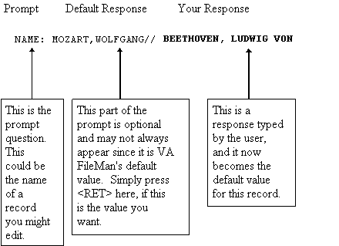
Figure 51: VA FileMan Prompts

Responding to Prompts

When VA FileMan prompts you for a response, typically a colon (:) is used at the end of the prompt; the computer waits for a response. Prompts are often asking for the value of a field in a file, like the one shown below:

DATE OF BIRTH:
Figure 52: Prompts Asking for a Response

This type of prompt is waiting for you to enter a value, like 3 OCT 49. Don't forget to complete your interaction by pressing the Enter/Return key (<Enter>).

If the answer to the prompt question is a choice of several things, the prompt often starts with the word "Select", as in:

Select PATIENT NAME:
Figure 53: "Select-type" Prompts, Offering a Choice

If the question requires either a YES or NO response (in which case simply Y or N, upper- or lowercase, is acceptable), the prompt may end with a question mark, rather than by a colon:

ARE YOU SURE?
Figure 54: "Yes/No-type" Prompts

For more information on the specific types of fields (DATE/TIME, NUMERIC, WORD-PROCESSING, FREE TEXT, etc.) and how to edit them, please refer to Chapter 6, "About Each Field Type," in this manual.

Getting Online Help at Any Prompt (Enter ? or ??)

If you're not sure how to answer a prompt, Help is always available. Just enter one question mark (?) to get brief Help, or two question marks (??) to get more detailed online help:

? | Entering a single question mark at a prompt gets a single line of Help.
?? | Entering two question marks at a prompt gets more detailed Help: a description of what values are acceptable, and/or a list of choices appropriate to the prompt where you entered the question marks.

Incorrect Responses

VA FileMan checks each answer to a prompt immediately after you enter it. If you answer a prompt incorrectly, VA FileMan "beeps," and displays two spaces and two question marks. You may be given an explanation of what was incorrect. Then, you're given a chance to respond to the prompt again.

Partial Responses

When you are choosing one of a set of responses, you can save keystrokes by not typing the full response. Type in only the first letter of first few letters representing the response that you desire. If the characters you enter uniquely identify one of the possible acceptable responses, VA FileMan "echoes back" the remaining characters and uses the matching choice as your response.

If more than one possible answers begin with the character(s) that you typed, VA FileMan displays the possible choices in a list, and asks you to choose which choice you want by number:

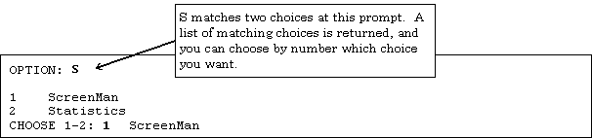
Figure 55: Choosing from a List in VA FileMan

Default Responses

When you're working in VISTA applications, the computer frequently present a default answer along with a prompt. This answer is built into the application program and represents the most probable response to the prompt that is being asked. These default answers are clearly identified by the double slash marks that follow them (//). If the default answer that is provided is correct, you need only press the Enter/Return key to accept it.

For example:

SSN: 000123124//
Figure 56: Prompts with Default Responses

In this case, if you press the Enter/Return key, 000123123 is posted as your response to this prompt.

If, on the other hand, the default answer isn't what you need, enter the correct information at the prompt. For example:

SSN: 123123124// 000234563 <Enter>
Figure 57: Overriding the Default Response to a Prompt

When editing data stored in fields, defaults are used to present the current value of the field. As with any default prompt, if you just press the Enter/Return key, the current value of the field is left unchanged. To change the value of the field, enter a new value and press the Enter/Return key.

Longer Default Responses and the "Replace…With" Editor

When a default is 20 or more characters in length, it won't be followed by double slashes (//). Instead, it is presented with a "Replace" prompt:

ADDRESS 1: 301 Bayshore Boulevard Replace
Figure 58: Long Responses Employing the "Replace...With" Editor

The "Replace" prompt employs the "Replace...With" Editor. At the "Replace" prompt, you can revise some or all of the existing default answer. To revise only a piece of the existing default response, type in any series of letters that are part of the existing default answer that you want to change and then press the Enter/Return key. At the "With" prompt, enter the series of characters to replace the original series, and press the Enter/Return key. At this point, the "Replace" prompt is presented again, so that you can enter additional corrections. If you're all done, however, just press the Enter/Return key to finish working in the field and move on to the next prompt.

For example:

ADDRESS 1: 301 Bayshore Boulevard Replace Bay <Enter> With North <Enter>
Replace <Enter>
301 Northshore Boulevard
ADDRESS 2:
Figure 59: Changing a Long Response Using the "Replace...With" Editor

To replace the entire default answer at a "Replace...With" prompt, simply enter three periods (…), called an ellipsis, at the "Replace" prompt. You are then able to replace the entire default with what you enter at the "With" prompt:

ADDRESS 1: 301 Bayhshore Boulevard Replace ... <Enter> With 301 Folsom Street <Enter>
Replace <Enter>
301 Folsom Street
ADDRESS 2:
Figure 60: Replacing an Entire Entry using the Ellipsis (...)

If you want to delete the entire text, enter the at-sign (@) at the "Replace" prompt:

ADDRESS 1: 301 Bayshore Boulevard Replace @ <Enter>
SURE YOU WANT TO DELETE? Y <Enter> (Yes)
ADDRESS 2:
Figure 61: Deleting an Entire Entry Using the At-sign (@)

The at-sign (@) is the command in many places to signal deletion, as you'll learn later in this chapter.

"Replace..." Prompt Shortcuts

The following table illustrates shortcut responses when entering data at the "Replace" prompt:

Shortcut | Action
... | Replaces everything.
xxx... | Replaces everything starting from the characters "xxx" to the end.
...xxx | Replaces everything from the beginning up to and including the characters "xxx".
xxx...yyy | Replaces everything starting from "xxx" up to and including "yyy".
end or END | Appends what you enter at the "With" prompt to the end of the value.
Table 11: "Replace" Prompt Shortcuts

Prompts with a List of Choices

If the acceptable answer to a field prompt is one of a set of choices, you can display the list of choices by entering one or two question marks. If that set of choices is short enough to be displayed on five or six lines, the choices are listed when you enter a single question mark.

Here's an example.

Select PATIENT NAME: ? <Enter>
ANSWER WITH PATIENT NAME
CHOOSE FROM:
FMPATIENT,SEVEN
FMPATIENT,18
FMPATIENT,19
Answer must be 3-30 characters in length.

Select PATIENT NAME:
Figure 62: Displaying a List of Choices

When you enter a question mark (?) and the entry list is long, you're asked if you want to see all the entries. Besides a YES or NO response, you can enter a caret ("^") followed by a string of characters to see a list of all entries beginning with the one that starts with those characters.

The following example shows selection of an entry starting with an alpha character:

Select PATIENT NAME: ? <Enter>
ANSWER WITH PATIENT NAME, OR SSN
DO YOU WANT THE ENTIRE 1890-ENTRY PATIENT LIST? ^S <Enter>
CHOOSE FROM:
FMPATIENT,20
FMPATIENT,21
FMPATIENT,22
FMPATIENT,23
'^' TO STOP ^ <Enter>

YOU MAY ENTER A NEW PATIENT, IF YOU WISH
Enter patient name in "Last, First Middle" format [3-30 characters].

Select PATIENT NAME:
Figure 63: Displaying a Subset of Choices from a List

If you know the list is long and still want it to be displayed, you can enter two question marks (??) to force the display of the entire list.

Key Fields

During a data entry session, VA FileMan checks that the combination of fields that make up a key for a record is unique for all records in the file. If a single field makes up a key, VA FileMan checks for uniqueness as soon as that field is edited. If more than one field makes up a key (compound key), VA FileMan checks that the combination of new key field values is unique only at the end of the data entry session (unless otherwise instructed by the programmer). If a compound key is not unique, VA FileMan restores the fields that make up the key to their pre-edited values, and prints a message.

For example:

Select ZZTEST NAME: `16 <Enter> FMPATIENT,THREE 9900 SEP 03, 1932
ID NUMBER: 9900// 9800
DATE: SEP 3,1932// 1/21/1932 <Enter> (JAN 21, 1932)

***** NOTE *****

Some of the previous edits are not valid because they create one or more
duplicate keys. Some fields have been restored to their pre-edited
values.

Do you want to see a list of those fields? YES// <Enter>

The following field(s) have been restored to their pre-edited values:

File: ZZTEST File (#16999)
Key: A
Record: 'FMPATIENT,THREE' (#16)

Field: ID NUMBER(#1)
Invalid value: 9800
Restored to: 9900

Field: DATE (#2)
Invalid value: JAN 21, 1932
Restored to: SEP 03, 1932
Figure 64: Entering a Duplicate Compound Key

Special Responses to Field Prompts

Deleting a Field's Value (@)

When you want to delete an answer previously entered, without substituting any other answer, enter an at-sign (@) as a response to that prompt:

DATE OF BIRTH: May 21, 1946// @ <Enter>
SURE YOU WANT TO DELETE? YES
Figure 65: Deleting a Field Entry

In this example, the date on file would be erased: there is no answer to the DATE OF BIRTH question; its value is now null. You're asked to confirm the deletion; this gives you a chance to change your mind before deleting the field.

Jumping to Another Field with the Caret ("^")

If you fail to notice a typing error until after you've pressed the Enter/Return key and stored a field, you can still correct this error. What you need to do is go back to the field where the error occurred. You can usually accomplish this by using the jump command. This command requires entering a caret ("^") along with the name, or first few letters, of the field to which you wish to jump. Instead of moving to the next prompt, you jump to the prompt you identified, as shown below:

SSN: 000123123// ^DATE OF BIRTH <Enter>
DATE OF BIRTH:
Figure 66: Using the caret ("^") key to "Jump" to a specific Field

To get a list of the fields to which you can jump, enter a caret and a question mark (^?) at any field prompt.

You can use the caret to jump both forward and backward in a sequence of fields.

Sometimes, you may only need to update one field in a record. You can jump directly to that field once you start to edit that record. This can save time; you don't need to go through every field and prompt that precedes the one you want!

Exiting with the Caret ("^")

To exit or opt out of answering any question or prompt, enter the caret ("^") by itself at the field prompt, as in the example below:

SSN: 000123123// ^
Select PATIENT NAME:
Figure 67: Using the caret ("^") key to Exit a Prompt

In the previous example, the field value 000123123 remains unchanged, but you skip the rest of the questions for this record and return to the "Select..." prompt. If you enter a caret ("^") at the "Select..." prompt, you return to the previous prompt, and so on.

Entering the caret ("^") by itself to exit a given function is a convention used throughout VISTA applications.

Exiting with the Caret (^^)

When the user is doing a lookup to the file, VA FileMan may search many indexes looking for a value that matches the users input. This can be time consuming. If the user wants to get out of the lookup before VA FileMan has completed the search, the user can enter "^^" at any prompt.

Mandatory (Required) Fields

In some cases a field is mandatory, and you must enter a value, if one isn't already there; in other words, a null response (i.e., pressing the Enter/Return key without making an entry) is not valid. When you use the caret ("^") or press the Enter/Return key without entering data in one or more fields in the entry, your terminal "beeps" and prompts you again to enter information.

If you don't fill in all required fields in a record, it is considered incomplete, and won't be stored unless you fill in the required fields. This protects the database from records containing so little information that they are useless. Enter the requested information.

If you still need to exit before you can provide all required information, you should abort your edit and start over later. You can usually exit out of the data editing sequence by answering any of the prompts with a caret ("^").

Spacebar Recall

VA FileMan can recall your most recent response to a prompt. This feature is called Spacebar Recall and employs the Spacebar (<Space>) and Enter/Return (<Enter>) keys. For example, if you are editing a particular patient in a Nursing application and then switch to the Order/Entry application to work with the same patient, you can usually retrieve the same patient by pressing the Spacebar and the Enter/Return keys at the second application's (Order/Entry) "Select PATIENT NAME:" prompt.

For example:

Select PATIENT NAME: <Space><Enter>
FMPATIENT,24
NAME: FMPATIENT,24//
Figure 68: Using the Spacebar Recall Functionality

You can use Spacebar Recall throughout VA FileMan and the Kernel. Experiment with this feature as a quick way to recall your last response to most prompts.

Typical Data Entry Session

So far we have discussed responding to individual prompts. Here is an example of a typical data entry session. The example is characteristic of editing data in many VISTA applications:

Select Patient (Name or SSN): FMPATIENT, <Enter> 25 01-12-41
000456789 COLLATERAL

Height: 5' 4"// <Enter>
Weight: 150#
Date Weight Taken: TODAY// <Enter> (MAY 17, 1995)
Usual Weight: 145#
Wrist Circumference (cm): <Enter>
Frame Size (SMALL,MEDIUM,LARGE) MED// <Enter>

Calculation of Ideal Body Weight
H Hamwi
M Metropolitan 83
S Spinal Cord Injury
E Enter Manually

Method: S <Enter>

Extent of Injury:
P Paraplegic
Q Quadriplegic

Select: P <Enter>

Select Ideal Weight (109-118) 114 lb // <Enter>
Does Patient have an Amputation? NO// <Enter>
Do you wish Anthropometric Assessment? NO// <Enter>

Collecting laboratory data ...

Calculate Energy Requirements Based On:

1 Actual Body Weight
2 Ideal Body Weight
3 Obese Calculation

Choose: 1 <Enter>

Comments:
No existing text
Edit? NO// <Enter>

Do you wish to FILE this Assessment Y// <Enter>
Figure 69: An Example of a Typical Data Entry Session

The fields in the session listed above take many different responses. Some accept FREE TEXT values, some accept only DATE/TIME, and some accept only NUMERIC input.

For more information on the specific types of fields (DATE/TIME, NUMERIC, WORD-PROCESSING, FREE TEXT, etc.) and how to edit them, please refer to Chapter 6, "About Each Field Type," in this manual.

About Each Field Type

So far, you've been introduced to several fundamental VA FileMan conventions, including:
- When the cursor comes to rest in a field, the computer expects you to respond.
- A field serves much the same purpose as a blank on a form.
- Each field has a prompt that identifies your response's subject matter.
- You have a number of tools available to you at field prompts, including the caret ("^") jump, default response, "Replace...With" editor, spacebar recall, and at-sign (@) deletion.
- Some fields have additional restrictions, such as your response's length or format. Enter a single or two question marks (? or ??) to retrieve Help on what is an acceptable entry for a particular field.

When you are editing a field, entering a question mark (?) at the field prompt usually provides enough help to infer what kind of field you've reached and to predict what kind of data is acceptable in this field.

You won't need to know a lot about these field types, but a little information can be helpful. In the pages that follow, you'll find examples and brief explanations about each field type (i.e., DATA TYPE). In VA FileMan, you'll work with many, if not all, of the following field types:
- DATE/TIME
- NUMERIC
- SET OF CODES
- FREE TEXT
- WORD-PROCESSING
- COMPUTED
- POINTER TO A FILE
- VARIABLE-POINTER

In addition, Subfiles (Multiples) are introduced at the end of this chapter.

DATE/TIME Fields

You can use a variety of formats when entering dates. For example, a DATE/TIME field would probably be used to hold a patient's birthdate:

DATE OF BIRTH: MAR 3, 1955
Figure 70: Entering a Date at a DATE/TIME Field

With the DATE/TIME field type, as with all field types, entering a question mark retrieves Help on acceptable responses. Enter a single question mark (?) at a DATE/TIME field prompt and you'll be given Help about what dates are acceptable for the particular field and what precision of date is needed (year, month, day, or time).

Acceptable Formats for Entering Dates:
- JULY 20, 1999 or July 20, 1999
- 7/20/99
- 20 JUL 99
- 10jul99
- 10 jul 99
- 072099

To simplify entering dates, you can use shortcuts such as T for today, T-1 for yesterday, or T+1 for tomorrow. Or you can combine T with D for day, W for week, or M for month; T-2D means two days ago, T+1W means today plus one week, and T+4M means four months from today.

The year portion of the date can be left off. Normally, VA FileMan assumes the current year. Sometimes, you can input imprecise dates such as "JUL 99" or "1999".

VA FileMan is Year 2000 (Y2K) compliant.

Abbreviations for Dates

The following table illustrates acceptable abbreviations when entering dates:

Abbreviation | Meaning
TODAY or Today or T or t | Today.
TODAY+1 or T+1 or t+1 | Tomorrow.
TODAY-7 or T-7 or t-7 | One week ago.
TODAY+3W or T+3W or t+3w | Three weeks hence.
Table 12: Abbreviations for Dates

Times in DATE/TIME Fields

In some DATE/TIME fields, you can enter a time-of-day along with the date. For example, to indicate 4:00 PM on July 20, 1999, enter the date in one of the formats shown above, followed by an at-sign (@), followed by the time.

For example, you might enter:

APPOINTMENT: 20 JUL 99@4PM
Figure 71: Entering a Date and Time

To be totally unambiguous, you can enter time as military time (four or six digits, no colon), hour AM/PM, hour:minute AM/PM, or hour:minute:second AM/PM. If you do omit an AM/PM notation, the following assumptions are made:
- If you enter a single digit for the hour, a time between 6AM and 6PM is used. Thus, T@330 (or T@3:30) means today at 3:30 PM and T@945 (or T@9:45) means today at 9:45 AM.
- If you enter two digits for the hour, the actual hour entered is used (as if military time were being used). Thus, T@0330 (or T@03:30) means today at 3:30 AM.

As with dates, there are supported abbreviations you can use when entering times in DATE/TIME fields. For example, to enter the present moment, you can enter the word NOW. To enter an hour from the present moment, enter NOW+1H. To enter an hour ago from the present moment, enter NOW-1H. You can also combine NOW with D for day and M for month and ' (apostrophe) for minute. You can also enter MID for 12 a.m. and NOON for 12 p.m.

Abbreviations for Times

The following table illustrates acceptable abbreviations when entering time:

Abbreviation | Meaning
NOW+3' | Present time plus three minutes.
NOW+1H | Present time plus one hour.
NOW+3D | Present time plus three days.
NOW+4M | Present time plus four months.
NOON | Today at 12:00 noon.
MID | Today at 24:00 midnight.
Table 13: Abbreviations for Times

NUMERIC Fields

NUMERIC-type fields work very much like FREE TEXT fields, except that input is restricted to valid numbers. There can also be restrictions as to how small or large a number is allowed, and how many decimal places are allowed. Entering a question mark retrieves Help that tells you what responses are acceptable.

For example, a NUMERIC field would probably be used to store the height of a patient:

HEIGHT (cm): 196
Figure 72: An Example of a NUMERIC Field

SET OF CODES Fields

SET OF CODES-type fields (sometimes referred to as a SET) are preset to accept coded information. The codes are usually only one or two characters long. Each code in a SET represents a word or a series of words. The codes Y and N, for example, often represent the words YES and NO. You can enter the code at this prompt instead of the entire word. If, however, you enter anything other than an acceptable code (or the word it represents), the computer will reject your response.

To see a list of acceptable codes, simply enter a question mark in response to the prompt.

The following example shows how a SET OF CODES field is used to store whether or not a patient is a smoker:

Select PATIENT NAME: FMPATIENT,NINE
SMOKER: ?
Choose from:
S SMOKER
N NON-SMOKER
SMOKER: N NON-SMOKER
Figure 73: An Example of a SET OF CODES Field

Internal vs. External Values for SET OF CODES Fields

In the previous example, the value of the SMOKER field is set to N, which is the code for NON-SMOKER. In this case, N is the internal value of the field (the form in which it is stored in the database). NON-SMOKER is the external value of the field (the form in which it is displayed on screen and in reports).

Every DATA TYPE has an internal and external value; in most cases, however, the internal and external values are the same. SET OF CODES fields are an exception.

Probably, the only place you need to know the distinction between internal and external values is when you print a report and sort on a SET OF CODES field. The sort order is based on the internal values (codes) if you sort on a SET OF CODES field.

For more information on printing and sorting, please refer to Chapter 2, "Print," in this manual.

FREE TEXT Fields

You can enter almost any character from your keyboard in a FREE TEXT-type field. The computer accepts numbers, letters, and most of the symbols that can be entered. The FREE TEXT field places a restriction on the number of characters that you can enter. If you enter a question mark (?) in response to the prompt for a FREE TEXT field, you'll learn how many characters you are allowed to enter.

For example, a FREE TEXT field would probably be used to hold a patient's street address:

ADDRESS: 235 Begonia Street
Figure 74: An Example of a FREE TEXT Field

In some places, even though the field is FREE TEXT, checks are applied to make sure what is entered matches a certain format. For example, if you're entering a Social Security Number (which is stored as a FREE TEXT, not NUMERIC, field), your input would typically be checked to make sure it is nine characters in length, and contains all digits:

SSN: abcde <Enter> ??
ANSWER MUST BE 9 CHARACTERS IN LENGTH
SSN: 99999 <Enter> ??
ANSWER MUST BE 9 CHARACTERS IN LENGTH
SSN: 33233290 <Enter> ??
ANSWER MUST BE 9 CHARACTERS IN LENGTH
SSN: 000232343 <Enter>
DATE:
Figure 75: An Example of a FREE TEXT Field with Validation

WORD-PROCESSING Fields

Fields with a WORD-PROCESSING DATA TYPE can contain unlimited amounts of text data, and are suitable for things like mail messages, physician notes, and descriptions. Because of their special nature, VA FileMan provides special tools for entering and editing data into this kind of a field.

Two editors for editing WORD-PROCESSING fields are provided with VA FileMan (and described in their own chapters in this manual):
- Screen Editor (Chapter 10)
- Line Editor (Chapter 11)

To set your default editor, please refer to Chapter 9, "Choice of Word Processing Editors," in this manual.

This chapter also explains how you can switch your current editor on the fly. For most people, the Screen Editor should be your Preferred Editor for WORD-PROCESSING fields.

When you encounter a WORD-PROCESSING field, if your default editor is the Screen Editor, a portion of any existing text is displayed, and you'll be prompted "Edit? NO//":

Select PATIENT NAME: FMPATIENT,22
NAME: FMPATIENT,22// <Enter>
SEX: MALE// <Enter>
DATE OF BIRTH: AUG 22,1948// <Enter>
HISTORY:
Owing to poverty in early youth, patient seems not to
have had proper diet. Since achieving economic success,
his diet has been adequate, but traces of original
deficiency remain.

Edit? NO//
Figure 76: An Example of a WORD-PROCESSING Field, Using the Screen Editor

For a guide to using the Screen Editor, please refer to Chapter 10, "Screen Editor," in this manual.

When you encounter a WORD-PROCESSING field, if your default editor is the Line Editor on the other hand, a portion of the text is displayed, and you'll be prompted with "Edit Option:"

Select PATIENT NAME: FMPATIENT,22
NAME: FMPATIENT,22// <Enter>
SEX: MALE// <Enter>
DATE OF BIRTH: AUG 22,1948// <Enter>
HISTORY:
1>Owing to poverty in early youth, patient seems not to
2>have had proper diet. Since achieving economic success,
3>his diet has been adequate, but traces of original
4>deficiency remain.

EDIT OPTION:
Figure 77: An Example of a WORD-PROCESSING Field, Using the Line Editor

For more information on the Line Editor, please refer to Chapter 11, "Line Editor," in this manual.

COMPUTED Fields

COMPUTED-type fields are typically used to output a value computed at run-time in a report. You can't edit the value of a COMPUTED field.

An example of a COMPUTED field would be a field that calculated AGE based on today's date and a patient's DATE OF BIRTH field. Because the field is a COMPUTED DATA TYPE, it can output a patient's current age based on whatever today's date is. You can't edit the AGE field, but you can use it to print out the current age of the patient.

You're most likely to come across COMPUTED fields when printing with the CAPTIONED PRINT template. Choosing the CAPTIONED OUTPUT template automatically outputs all normal fields containing data for each entry in a report. However, you must choose whether you want COMPUTED fields included in the output as well:

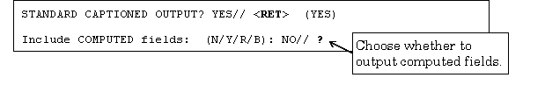
Figure 78: An Example of a COMPUTED Field

For more information on CAPTIONED OUTPUT, please refer to Chapter 1, "Inquire," and Chapter 2, "Print," in this manual.

POINTER TO A FILE Fields

A POINTER TO A FILE-type field is a field that directs the computer to another file for information. If you're working in the PATIENT file, for example, and you've reached a field that asks for the patient's STATE, the field is probably a POINTER TO A FILE field that "points" to the STATE file. Because of pointers, such commonly used information as states can be stored in a single STATE file. Then, every file (PATIENT, VENDOR, INSURANCE, etc.) that needs to record a value for STATE can use a POINTER TO A FILE field to the STATE file to store that information.

For example:

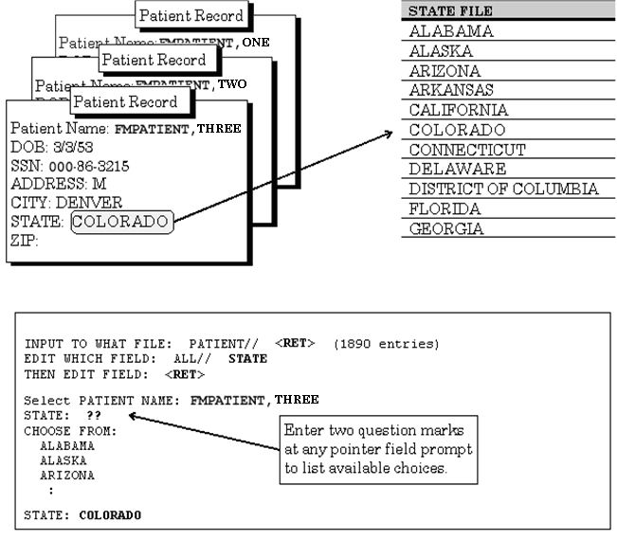Figure 79: An Example of a POINTER TO A FILE Field

If the choice you need is not listed, you can add that choice by typing it in (provided you have LAYGO access to add the entry). If the entry you enter is not matched, you're asked if you want to add a new entry. If you answer YES, VA FileMan adds the new entry. For example, if there was a state that did not have an entry in the STATE file, you could add it by entering it at the "STATE:" field prompt.

VARIABLE-POINTER Fields

A VARIABLE-POINTER-type field is like the regular POINTER TO A FILE field type, with one difference: the VARIABLE-POINTER DATA TYPE can point to a single record in one of several files, whereas the regular POINTER TO A FILE DATA TYPE can point to a single record in only one file. The PATIENT file, for example, might use a VARIABLE-POINTER to identify a Provider; the Provider might be a Staff Provider, stored in the PROVIDER file, or an Outside Provider, stored in another file.

Let's say you're working in a PATIENT file entry, and you need information that explains how to look up a name listed in one of several files. To get Help, simply enter a single question mark (?) at the "PROVIDER" prompt. Now, on your screen, you'll see instructions that explain how to choose a Provider from either of the two files being pointed to:

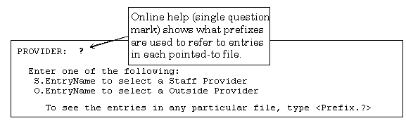
Figure 80: An Example of a VARIABLE-POINTER Field

With VARIABLE-POINTER fields, you need to use a PREFIX in addition to an entry name to select an entry. In this example, the online Help tells you that to select a Staff Provider, prefix the Provider's name with "S.". To select an Outside Provider, prefix the Provider's name with "O.".

You can enter a PREFIX and a question mark to get a list of entries in a particular pointed-to file. For example, if you enter "S.?" you can get a list of all Staff Providers. Likewise you can enter "S.FMPROVIDER" to get a list of all Staff Providers whose last names are FMPROVIDER. You can also enter "S. FMPROVIDER,ONE" to select a Staff Provider named One Fmprovider.

For example:

PROVIDER: S.?
CHOOSE FROM:
FMPROVIDER,ONE J.
FMPROVIDER,TWO J.
:
Figure 81: Using the PREFIX and a Question Mark to Get a List of Entries in a Pointed-to File

You can also select an entry in a VARIABLE-POINTER field by just entering a name without the PREFIX. In this case, VA FileMan searches each pointed-to file in succession until a match is found.

This method requires more processing time, since VA FileMan will need to search the various pointed-to files.

For example, to choose a Provider without specifying in which file the Provider can be found, enter the Provider name only:

PROVIDER: FMPROVIDER,EIGHT M

Searching for a Staff Provider

Searching for a Outside Provider FMPROVIDER,EIGHT M
...OK? YES// <Enter> (YES)
Figure 82: Searching for an Entry in a Pointed-to File

You can add an entry to one of the files that is being pointed to by a VARIABLE-POINTER field. To do this, enter the appropriate PREFIX and the new name to add at the field prompt.

For example, to add " FMPROVIDER,EIGHT M" as an Outside Provider (not a Staff Provider), use the appropriate PREFIX when adding the new entry (in this case, "O."). When the requested name is not found, you're asked if you want to add the Provider as a new entry. To add the entry, enter YES:

PROVIDER: O.FMPROVIDER,EIGHT M.
Are you adding 'FMPROVIDER,EIGHT M.' as a new OUTSIDE PROVIDER? No// YES <Enter> (Yes)
OUTSIDE PROVIDER SEX: MALE
OUTSIDE PROVIDER DATE OF BIRTH: 020235 <Enter> (FEB 02, 1935)
OUTSIDE PROVIDER SSN: 000987321
Figure 83: Adding a New Entry to a Pointed-to File

Subfiles (Multiples)

Sometimes, a single field in a record is not enough to hold all the information required. For example, to keep track of the appointment history for a patient, a single field would not be enough. An ordinary field could only hold enough information to record a single appointment. But there needs to be a way to record as many appointments as a patient has had, which could range from none to several hundred. In addition, each appointment might have its own information that needs to be stored, such as date, time, location, doctor, etc.

This situation is handled with what are known as Subfiles (also known as Multiples). Within an individual record, a Subfile (Multiple) can be used to hold this type of information:

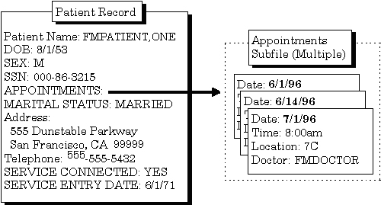
Figure 84: An Example of a Subfile (Multiple) Field

The fields in a Subfile (in this example, DATE, TIME, LOCATION, and DOCTOR) are called Subfields.

The word "Select" is always the first part of the prompt when you encounter a Multiple, to indicate that you are choosing among one of several possible values on file:

Select APPOINTMENTS:
Figure 85: An Example of a Multiple Field Prompt

If, for a given Multiple, more than one entry has already been entered, the most recently created entry is displayed as a default. To see the list of entries already in the Multiple, enter two question marks (??) at the "Select..." prompt.

Because they are so useful, Subfiles (Multiples) are widely used throughout VISTA. They are usually straightforward to use, because their structure as Subfiles mirrors the real-world structure of the information. For example, for a purchase order, the top-level record would be the purchase order. Because a single purchase order needs a place to store as few or as many items as are requested, the purchase order record has a Multiple to record the order items for the purchase order.

Subfiles can themselves contain Subfiles creating additional levels in files.

Adding and Deleting Records

.01 Field

The ".01 field" is the most important field in a file. For the records in a file, it usually identifies the record more than any other single field; for example, the .01 field of the PATIENT file is NAME. The .01 field of a WARD file might be WARD NAME.

Usually in an edit dialogue, the .01 field is the field you are prompted for when you choose a record to edit. Typically it's also the first field you actually edit once you've chosen the record.

The .01 field plays a role in both adding and deleting entries in a file. To add an entry to a file, you usually enter a new value at the .01 field's prompt. To delete an entry to a file, you usually enter an at-sign (@) in the entry's .01 field.

How to Add a Record

As you may recall from the "Introduction" chapter, an entry is a complete record in a file. To add a new entry to a file, enter the name of the new entry at the "Select..." prompt where you ordinarily choose which record in the file to edit:

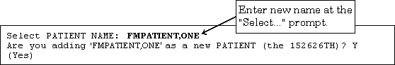
Figure 86: Adding a Record

This is the prompt for the record's .01 field (see above). If you enter a name that does not exist in the file, you are prompted "Are you adding 'XXXXXXXX' as a new 'ENTRY'?," where "XXXXXXXX" represents the field value and "ENTRY" represents the field or file name. If LAYGO is allowed and you answer YES to this prompt, VA FileMan will add the new entry to the file. You then go on to edit other fields for the new entry.

If a file has one or more data Keys defined (i.e., fields or combinations of fields that uniquely identify a record), then those fields must also be filled in before the new entry will be added. There must not be any other records on the file that have the same values in all of those fields.

Finally, there may be a set of required fields (identifiers) for the new entry; these must be filled in with values for the new entry to be saved.

Adding a Duplicate Record (Use Quotes)

What if there is already a "FMPATIENT,ONE" in the PATIENT file, and you need to add a second entry with the same name "FMPATIENT,ONE"? Simply entering that name at the "Select..." prompt selects the existing entry. To create a second FMPATIENT,ONE entry, even though one with that name already exists, enter the entry name you want to add, but with quotation marks around it:

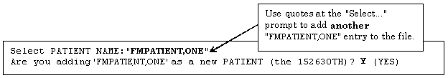
Figure 87: Adding a Duplicate Record

See the Adding Records at a POINTER TO A FILE Field topic below for instructions on adding entries with the same name to pointed-to files from POINTER TO A FILE DATA TYPE fields.

If a record has a data Key defined (i.e., fields or combinations of fields that uniquely identify a record), and if the data Key contains more than one field, then it would be possible to add a second FMPATIENT,ONE without using quotes. Suppose the Key fields were the NAME and the DATE OF BIRTH. Then the user would be prompted for both NAME and DATE OF BIRTH, and assuming that the DATE OF BIRTH of the second FMPATIENT,ONE were different from the existing record, VA FileMan would allow the user to add the new FMPATIENT,ONE without enclosing the name in quotes.

How to Delete a Record

To delete an existing record in a file, enter an at-sign (@) in the record's .01 field. This tells VA FileMan to delete the record. In all deletions, you're asked to confirm the deletion before VA FileMan goes ahead and deletes the record. Here is an example of deleting a record in a file:

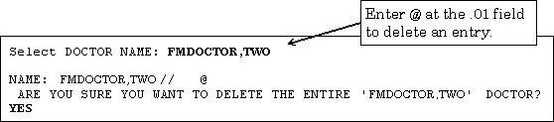
Figure 88: Deleting a Record

Repointing When Deleting Records

What if a record in another file points to the record you're deleting?

If you delete a record that is pointed to from another file, this would leave a dangling pointer that points to a non-existent entry. To prevent this, if the record you delete could be pointed to from another file, you're given the opportunity to either delete any pointers to the deleted record, or change them all to point to another record.

For example, an entry in the PATIENT file may have a field that points to a doctor in the PROVIDER file. If you delete the doctor from the PROVIDER file, you should say what should happen to any entries in other files, including PATIENT, that point to this doctor.

In the example below, when we delete the FMDOCTOR,TWELVE record, we will re-point any entries that had been pointing to FMDOCTOR, TWELVE to point to FMDOCTOR,EIGHT.

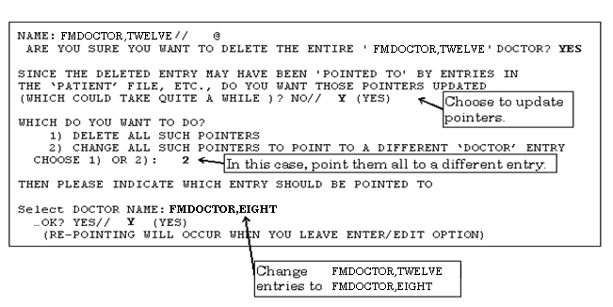Figure 89: Deleting a Record and Repointing to a Different Record

When you leave the Enter or Edit File Entries option, the updating is done. A report is generated listing all changed entries; you need to specify on what device this report should be listed:

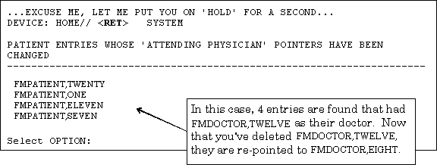

Adding Records to a POINTER TO A FILE Field

Suppose you're editing a POINTER TO A FILE-type field. This lets you choose an entry from another file to point to. If you have LAYGO access to the pointed-to file, you can also add new entries to it when editing the POINTER TO A FILE field.

For example, suppose you are editing the TITLE field in the NEW PERSON file, which is a POINTER TO A FILE type field that "points" to the TITLE file. What if you want to choose a TITLE that's not already in the TITLE file? You can add it as in the example below:

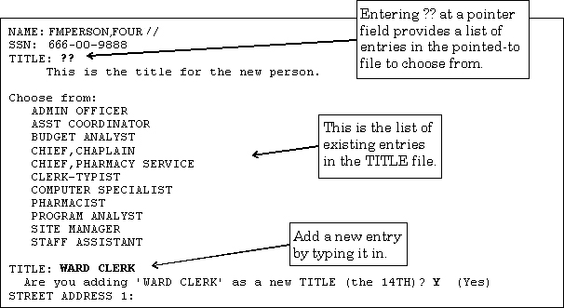
Figure 90: Adding a New Entry to a Pointed-to File

In this example, after adding WARD CLERK as a new entry, if you go back to the TITLE field and enter two question marks (??) again, WARD CLERK would be one of the choices listed for TITLE.

Adding Duplicate-Named Entries

You can force an entry to be added to the pointed-to file even if an entry with the same value already exists in the pointed-to file. To add a duplicate-named entry, surround the value to be added with one set of quotation marks, like this:

POINTER FIELD: "FORCED NEW ENTRY"
Figure 91: Adding a Duplicate-Named Entry to a Pointed-to File

If the POINTER TO A FILE field that you are editing happens to be the NAME (#.01) field of the current file, you can add entries to both the current file and to the pointed-to file by surrounding your value with two sets of quotation marks as follows:

POINTER FIELD (.01): ""FORCED NEW ENTRY""
Figure 92: Adding an Entry to both the Current File and to a Pointed-to File

Adding and Deleting from Multiples

Some special considerations apply when you are editing Multiple-valued fields. One example of a Multiple field is the DIAGNOSIS field in the PATIENT file. As you may recall from Chapter 6, "About Each Field Type," a Multiple is a field in a record that can store multiple Subrecords. In this case, VA FileMan must be able to store multiple diagnosis entries for a single patient, and it uses a Multiple field to do so:

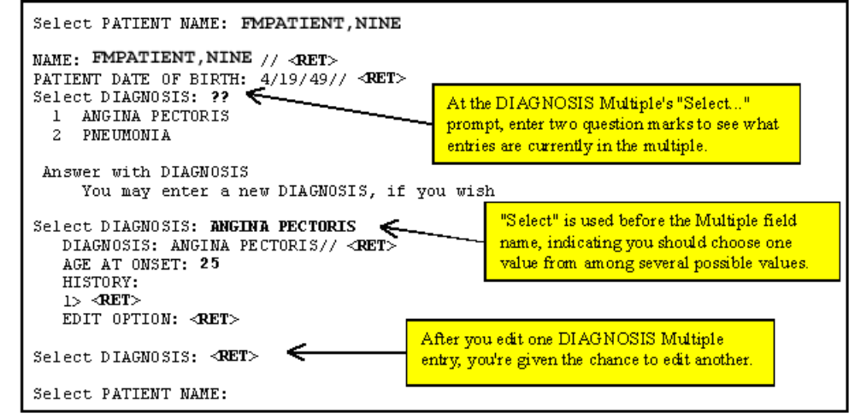
Figure 93: An Example of a Multiple Field

Multiples have .01 fields, just like records at the top level of a file. Thus, just as with records at the top level of a file, you select entries in the Multiple at the Multiple's "Select..." prompt. You can also add a new entry by typing it in at the Multiple's "Select..." prompt. You can delete an entry in a Multiple by entering an at-sign (@) in the existing entry's .01 field.

Enter a single question mark (?) at a Multiple's "Select..." prompt to retrieve brief Help for the field; enter two question marks (??) to choose from the list of entries in the Multiple.

Enter or Edit File Entries Option

In most cases you enter and edit data through application programs. Applications are pre-programmed to allow you to edit specific files, and often only a subset of the fields in any given file. The application shields you from many aspects of editing the file data, such as even knowing the name of the file you are working with. Usually, this information is already chosen for you by the application.

You can also edit data in a file directly, however, using VA FileMan's Enter or Edit File Entries option. Your ability to edit data in any given file depends on:
- Whether you have the Enter or Edit File Entries option on your menu.
- Whether you have access to edit the file in question.

The steps to use the Enter or Edit File Entries option are:

1. At the "INPUT TO WHAT FILE:" prompt, choose which file to edit. To see what files you have access to, you can enter two question marks (??) at this prompt:

INPUT TO WHAT FILE:??
Choose from:
335235 FMUSER'S DATA (7 entries)
335238 PROJECTS (3 entries)
335668 WARD HISTORY (178 entries)

INPUT TO WHAT FILE: PROJECTS
Figure 94: Choosing a File to Edit

2. At the "EDIT WHICH FIELD:" prompt, choose what fields to edit for each file entry. The easiest response is to just accept the default of ALL fields by pressing the Enter/Return key:

EDIT WHICH FIELD: ALL//
Figure 95: Choosing the File Fields to Edit

If, however, you want to edit only certain fields (not all fields), answer the "EDIT WHICH FIELD:" prompt with the name (or number) of the FIRST field you want to edit. You can then enter additional fields to edit (when you are done, press the Enter/Return key at the "THEN EDIT FIELD:" prompt). For a list of fields you can edit, enter two question marks at any "EDIT FIELD:" prompt.

EDIT WHICH FIELD: ALL// NAME
THEN EDIT FIELD: PROJECT SHORT DESCRIPTION
THEN EDIT FIELD: PROJECT ISSUE <Enter> (multiple)
EDIT WHICH PROJECT ISSUE SUB-FIELD: ALL// <Enter>
THEN EDIT FIELD: <Enter>
Select PROJECTS NAME:
Figure 96: Choosing Specific File Fields to Edit

3. You can now edit entries. Choose each entry to edit at the "Select...NAME:" prompt. Each time you choose an entry, you step through each field you specified in Step 2 above. When you are done with editing an entry, you are prompted for another entry to edit at the "Select..." prompt. When you are done editing entries, just press the Enter/Return key.

Here is an example of a typical data entry session using the Enter or Edit File Entries option:

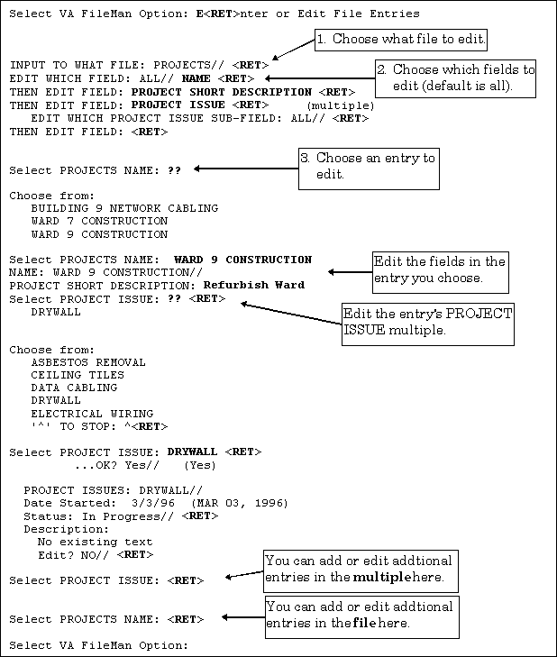
Figure 97: An Example Using the Enter or Edit File Entries Option

ScreenMan

ScreenMan is VA FileMan's screen-oriented data entry tool. It is an alternative to the Scrolling Mode approach. With ScreenMan, data is entered in forms. Each form field occupies a fixed position on the screen (instead of scrolling off!). You can see many data fields at once, and use simple key combinations to edit data and move from field to field on a screen. You can also move from one screen to another like turning through the pages of a book.

Similarities with Scrolling Mode Editing
- You can change a field's value by entering a different value or delete a field's value by entering the at-sign (@).
- You can enter one or two question marks to call up a list of acceptable responses and other help. If you enter a value deemed unacceptable, ScreenMan displays a message explaining what type of information should be entered.
- If you wish, you can jump from the current field to any other field in your current screen. With your cursor resting at any field's prompt, simply enter a caret ("^") and then the name of the field.

Differences from Scrolling Mode Editing
- In Scrolling Mode, you must enter and store your response to one field prompt before you can continue to the next field. In Screen Mode, you can move the cursor from field prompt to field prompt without entering or storing any responses.
- In Scrolling Mode, your data values or responses to field prompts are stored one at a time, as you move from prompt to prompt. In Screen Mode, your responses to most prompts are stored only when you exit the form.

For a detailed explanation on creating ScreenMan forms, please refer to the ScreenMan Tutorial for Developers Manual—available in both Adobe Acrobat PDF and HTML formats on the VA FileMan Home Page at:
http://www.va.gov/vdl/application.asp?appid=5

The ScreenMan Screen

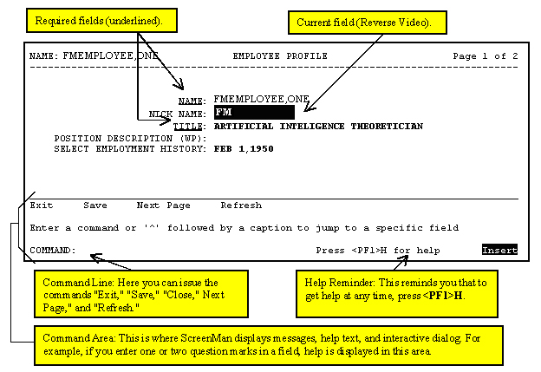
Figure 98: An Example of the ScreenMan Screen

Fields are usually composed of a data element and a caption. ScreenMan displays data elements in high intensity (boldface) and other text in regular intensity. Text that identifies a data element is called a caption and is usually followed by a colon (:). A caption and its associated data element are together called a field. Captions of required fields are underlined; to save any changes you make on the form, required fields must contain data.

ScreenMan highlights captions for required fields with an underline. However, on some terminals or depending on your terminal emulator software and your personal preferences, the form of the highlight can vary (e.g., some emulators will highlight required fields in a different color, with an underline, or both).

Specifically, on Qume 102 and Wyse 75 terminals, captions for required fields display in boldface, not underlined. Also, the edit window is displayed with an underline extending from the last character of the existing data to the right edge of the edit window.

Cursor Movement (Navigation Keystrokes)

How to Navigate Between Fields

There are a number of ways you can move the cursor from field to field on a form (i.e., navigate). This is to provide you with as much flexibility as possible so that you can work quickly and efficiently with forms.

You can use the keystrokes listed in the following table to move the cursor to various fields located on a ScreenMan form:

To | Press
Move to the next field (to right or below). | <Tab>
Move to the previous field (to left or above). | <PF4>
Move to the field above. | <ArrowUp>
Move to the field below. | <ArrowDown>
Move to the next field in the pre-defined edit sequence. | <Enter>
Edit a WORD-PROCESSING field. | At field, press <Enter>
Select a Subrecord in a Multiple. | At field, press <Enter>
Move to the next block on current page. | <PF1><PF4>
Jump to a specific field. | ^ followed by Caption of field and <Enter>
Jump to the Command Line. | ^<Enter>
Table 14: Keystrokes to Navigate Between Fields in a ScreenMan Form

How to Navigate Between Pages

Many ScreenMan forms have more than one page (i.e., there are additional screens besides the first one on the form) with additional fields that you can edit.

You can use the keystrokes listed in the following table to move between pages on a ScreenMan form:

To | Press
Move to next page | <PF1><ArrowDown> or  <PageDown>
Move to previous page | <PF1><ArrowUp> or  <PageUp>
Move to a page you specify | <PF1>P
Table 15: Keystrokes to Navigate Between Pages in a ScreenMan Form

Saving and Exiting

To SAVE or EXIT the form, you need to reach ScreenMan's command line. It's reachable from any ScreenMan screen. To reach the command line, do any one of the following:
- Enter a caret ("^") at any field prompt.
- Press <Enter>, <Tab>, or <PF4> to move from field to field until you reach the command line.
- Press <ArrowDown> or <ArrowUp> to move the cursor from field to field downwards or upwards, until you reach the command line.

Then you can enter SAVE or EXIT at the command line (see below).

Command Line Options (SAVE, EXIT, etc.)

From the Command Line, you can issue the commands to perform various functions while in ScreenMan. You can also use a shortcut key sequence to perform the same function without having to enter it on the command line.

Shortcut Keys

The following table illustrates the command line options and the corresponding shortcut responses while in a ScreenMan form:

Command Line Option | Shortcut | Description
EXIT | <PF1>E | Exits the form. If you have made any changes, ScreenMan asks if you want to save them before exiting.
SAVE | <PF1>S | Saves your changes without exiting the form.
REFRESH | <PF1>R | Repaints the page(s) on the screen, in case, for some reason, the information displayed on the screen has become corrupted.
NEXT PAGE | <PF1><ArrowDown> or  <PageDown> | (Available only on multi-page forms.) Goes to the next page of the form.
CLOSE | <PF1>C | (Available only on "pop-up" pages.) Closes the current page and returns you to the parent page.
(none) | <PF1>Q | Quit the form, discarding changes.
Table 16: Command Line Options and Shortcut Keystrokes in a ScreenMan Form

On a "pop-up" page, your only Command Line options are CLOSE and REFRESH.

Editing

How to Edit Fields

The following charts list the key sequences for ScreenMan's Field Editor, the editor that allows you to edit data fields on a ScreenMan Form.

Cursor Movement

The following table illustrates the keystrokes you use to move the cursor while in a ScreenMan form:

To Move | Press
Right one character | <ArrowRight>
Left one character | <ArrowLeft>
Right one word | <Ctrl-L> or <PF1><Space>
Left one word | <Ctrl-J>
Right edge of window | <PF1><ArrowRight>
Left edge of window | <PF1><ArrowLeft>
End of field | <PF1><PF1><ArrowRight>
Beginning of field | <PF1><PF1><ArrowLeft>
Table 17: Keystrokes to Move the Cursor in a ScreenMan Form

Deletion

The following table illustrates the keystrokes you use to delete characters while in a ScreenMan form:

To Delete | Press
Character under cursor | <PF2> or <Delete> or <Remove>
Character left of cursor | <Backspace>
From cursor to end of word | <Ctrl-W>
From cursor to end of field | <PF1><PF2>
Delete entire field / Restore last edit / Restore default | <PF1>D or <Ctrl-U>
Table 18: Keystrokes to Delete Characters in a ScreenMan Form

Modes

The following table illustrates the keystrokes you use to switch modes while in a ScreenMan form:

To Switch to | Press
Insert/Replace mode | <PF3>
Zoom editor (edit long fields) | <PF1>Z
Table 19: Keystrokes to Switch Modes in a ScreenMan Form

If the first key you press upon navigating to a field is a printable character, the Field Editor assumes you want to replace any existing default and replaces the entire field with the character just typed. To just edit the existing field value, first press an editing key, such as <ArrowLeft> or <ArrowRight>.

Long Fields (and the Zoom Editor)

The actual contents of a field being edited can extend beyond the confines of the visible field on a ScreenMan form. As you use the <ArrowLeft> and <ArrowRight> keys at the left and right edges of the window, you can scroll left or right to display one end or the other of the field.

To see and edit the entire contents of a long field at once, press <PF1>Z to invoke the Zoom Editor. This opens an area up at the bottom of the screen, providing you as much space as you need to both see and edit the entire long field.

WORD-PROCESSING Fields

To edit or display a WORD-PROCESSING field, press the Enter/Return key at the WORD-PROCESSING field. This clears the screen and passes control to your Preferred Editor to edit the field. If you do not have a Preferred Editor, the Screen Editor is used. When you exit the editor, you return to the ScreenMan screen.

To set your Preferred Editor, please refer to Chapter 9, "Choice of Word Processing Editors," in this manual.

If the WORD-PROCESSING field is uneditable or appears in a display block, you can view the contents of the field with an editor. However, if you edit the text, your changes will not be filed in the permanent database, even if you tell the editor to save the changes.

Multiples

You can easily spot a Multiple field. It usually begins with the word "Select" (as in "Select ADDRESS" or "Select ADMISSION DATE"). There are two ways Multiples can be displayed on a form:
- The Multiple is linked to a "pop-up" subpage, which contains the subfields of the Multiple.
- The Multiple is displayed in a repeating block -- several Subrecords can be displayed simultaneously on a page, much like a scrolling list.

Multiples Linked to "Pop-Up" Subpages

A Multiple field can appear on a page and be linked to a regular or "pop-up" subpage. When you navigate to the Multiple field, select a Subrecord, and press the Enter/Return key, you are taken to the subpage, which contains the fields within the Multiple.

In the following illustration, the Multiple is the field with the caption "Select EMPLOYMENT HISTORY:". When you enter "FEB 1,1950" at this field, you are taken into a "pop-up" subpage, where you can edit the fields for that particular Subrecord:

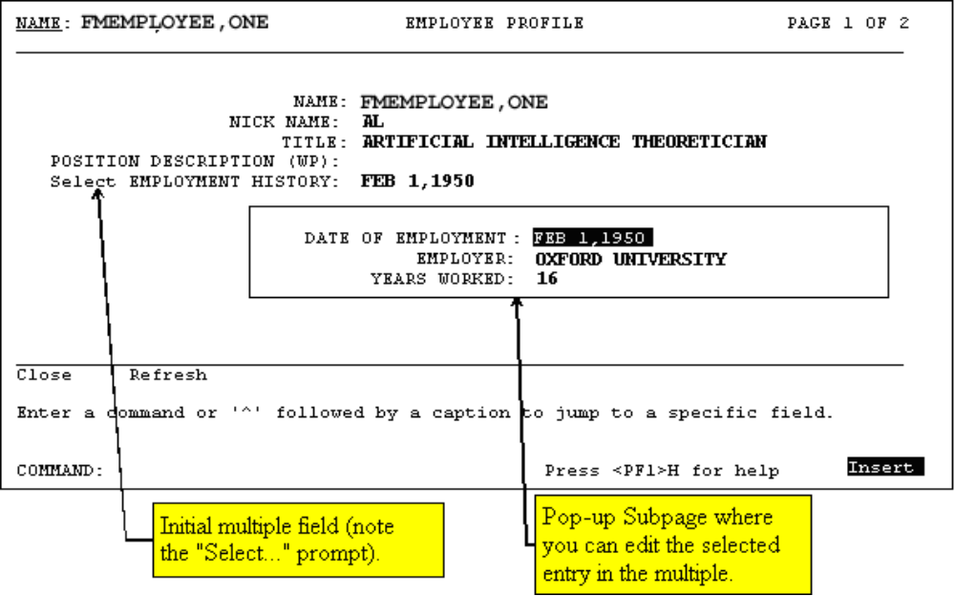
Figure 99: An Example of a "Popup" Subpage for a Multiple

Exiting a Subpage

While in a subpage, your only Command Line options are CLOSE and REFRESH. You cannot EXIT, Quit, or SAVE until you return to the parent page. You can return to the parent page by pressing <PF1>C or issuing the CLOSE command at the Command Line. From there, you can select another Subrecord to edit or navigate to another field.

Deleting an Entry in a Multiple

If a default Subrecord is displayed at a Multiple field, you can delete that Subrecord by entering an at-sign (@) at the Multiple field. You can also delete a specific Subrecord by selecting that Subrecord and going into the subpage, and entering an at-sign (@) at the .01 field.

Deletions of Subrecords are immediate and permanent even if you quit the form without saving, deleted Subrecords are not restored to the database.

Adding a New Entry to a Multiple

You can respond to a Multiple field in one of two ways:
- Accept the field's default answer.
- Enter a new item: an employee's second address, for example, or another admission date for the same patient.

Sometimes, you may need to enter a new entry in a Multiple. To do this, enter the new value for the new entry in the Multiple's .01 field. If you have LAYGO access (permission to add new entries), you'll be asked if you want to add the entry to the Multiple. To change your mind about adding the item, enter NO. If you enter YES, though, ScreenMan opens either a "pop-up" page or a new window, allowing you to enter additional information for the new Multiple entry.

Multiples in Repeating Blocks

Subrecords in a Multiple can be displayed in another way. Rather than just the name of single entry in the Multiple being displayed on the current page, you may also see Multiples where several Subrecords are displayed simultaneously on the page. Each Subrecord occupies one line on the screen, in a scrolling list. This is called a repeating block. Instead of leading to a "pop-up" page, you are able to edit all visible fields in the Multiple as they are displayed.

For example:

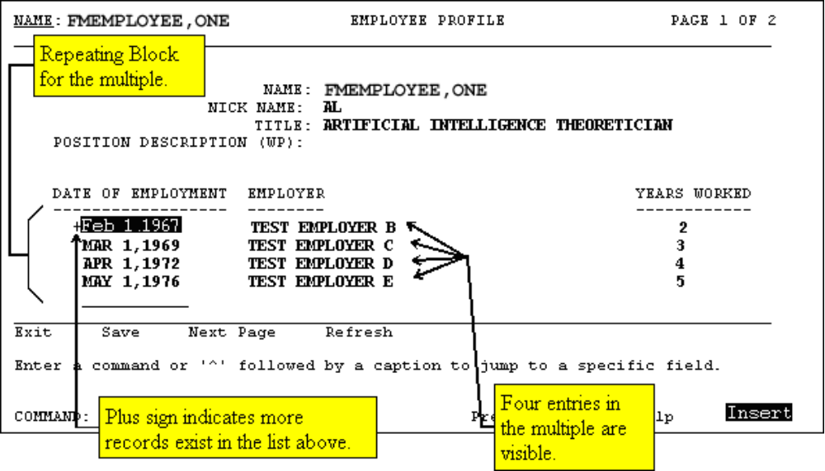
Figure 100: An Example of a Repeating Block in a Multiple

You can always navigate to a blank line below the end of the list. At this blank line, you can add a new Subrecord if LAYGO is allowed, or jump to an existing Subrecord by entering its name.

Navigational Keys for Repeating Blocks

The following table illustrates the keystrokes you use to navigate while in a Repeating Block in a ScreenMan form:

To | Press
Scroll through the list | <ArrowUp> and  <ArrowDown>
Page down through the list | <PF1><ArrowDown> or <PageDown>
Page up through the list | <PF1><ArrowUp> or <PageUp>
Jump to the blank line at end of list | ^<Enter> in a non-blank line
Jump to the Command line | ^<Enter> at the end of the list
Table 20: Keystrokes to Navigate Repeating Blocks in a ScreenMan Form

Details

How to File Edits

In general, the database is unaffected while you edit a record in a ScreenMan form. Changes are filed only at your request, when you SAVE or EXIT.

Before filing, ScreenMan checks that:
- Required fields on all pages that can be accessed via the next and previous page links have values, even if you have not accessed those pages during the editing session.
- If you have accessed any subpages, required fields in those subpages must also have values.

If any required field is empty, you cannot file any data changes. When you attempt to file, ScreenMan displays a list of those fields that require values.

The <PF1>Q key sequence allows you to quit the form without saving changes. Filing does not occur if you time out.

There is one situation in which a change to the database is made immediately: when you delete an entry from a file or subfile. When you attempt to delete an entry, ScreenMan issues a warning that deletions are immediate and permanent. Even if you quit the form without saving your changes, the entry is not restored to the database.

Troubleshooting

While screen displays offer many advantages, they also require that the software can correctly identify the type of terminal being used or emulated. An incorrect identification may produce unreadable and unusable screens. To exit such a screen, enter ^<Enter>^<Enter>.

If you continue to find the screens are unreadable, check the following sources for troubleshooting information:
- "System Management" chapter in the "Tools" section of the VA FileMan Advanced User Manual (e.g., the "Device Handling for Stand-alone VA FileMan" topic).
- Kernel Systems Manual (look for information on "Device Type at Sign-on" and changing your terminal type).
- Your system manager.

WORD-PROCESSING Fields

Choice of Word Processing Editors

WORD-PROCESSING-type fields are typically used so that you can write, edit, and format text for letters and reports, text information in patient records, electronic MailMan messages, application packages, responses, and so on.

VA FileMan provides two editors for WORD-PROCESSING fields: the Line Editor and the Screen Editor. Your system manager may provide other editors as well. Examples of Alternate Editors include: LetterMan and the Extensible Editor.

You can select any of the available editors on the system as your Preferred Editor. If you select a Preferred Editor, that editor will be used whenever you edit a WORD-PROCESSING field. If you don't choose a Preferred Editor, the following defaults are used:
- When editing WORD-PROCESSING fields from scrolling mode, the Line Editor is used.
- When editing WORD-PROCESSING fields from a ScreenMan form, the Screen Editor is used.

How to Select Your Preferred Editor

1. At any menu prompt, enter "TBOX" to go to the User's Toolbox menu.

2. Choose the Edit User Characteristics option from the User's Toolbox menu.

3. At the "Select TERMINAL TYPE NAME: " prompt, you can usually just accept the default by pressing the Enter/Return key (<Enter>).

4. You are now placed in a ScreenMan form where you can edit your user characteristics. Press <ArrowDown> until your cursor arrives at the "PREFERRED EDITOR:" prompt.

5. At the "PREFERRED EDITOR:" prompt, you can choose your Preferred Editor. Enter two question marks (??) to get a list of the available editors on your system. Choose one as your Preferred Editor and then press the Enter/Return key (<Enter>). The Screen Editor is usually a good choice.

6. Press <PF1>E to exit the ScreenMan form. If you are asked whether to save changes before leaving the form, answer YES.

Your Preferred Editor should now be set to the editor you've chosen. This is the editor that will be used whenever you edit the contents of a WORD-PROCESSING field.

Switching to Another Editor While Editing

Selecting your default editor determines which editor is used whenever you edit a WORD-PROCESSING field. However, if you want to temporarily switch to another editor once you've started editing, both the Screen Editor and the Line Editor allow you to do this:
- In the Screen Editor, press <PF1>A and choose the editor to which you wish to switch.
- In the Line Editor, choose the Utilities in Word processing option. Then choose Editor Change at the "Edit Option:" prompt, and choose the editor to which you wish to switch.

For more information on the Line Editor, please refer to Chapter 11, "Line Editor," in this manual.

For more information on the Screen Editor, please refer to Chapter 10, "Screen Editor," in this manual.

Screen Editor

To edit the contents of WORD-PROCESSING-type fields in files, you need to use a word processing editor. VA FileMan provides two standard editors: the Screen Editor and the Line Editor. The Screen Editor provides flexibility and freedom not provided by the Line Editor. The Screen Editor provides such features as full-screen editing, automatic text wrapping, and search-and-replace. In most cases you would want your default editor to be the Screen Editor.

For most people, the Screen Editor should be your Preferred Editor for WORD-PROCESSING fields.

For more information on the Line Editor, please refer to Chapter 11, "Line Editor," in this manual.

To set your default editor, please refer to Chapter 9, "Choice of Word Processing Editors," in this manual.

If you enter <PF1>H at any time in the Screen Editor, you can get online Help that lists all the available commands.

At any time, while entering text using the Screen Editor, you can select a command. For example, at any time you can change your left margin, move to a different screen, save your document, or get online Help. To invoke most commands, you need to enter only two keystrokes: the <PF1> key and a character key, such as D for delete line.

You'll usually find the <PF> keys at the right-hand side of your terminal keyboard, along with the numeric keypad. If you're using a personal computer rather than a computer terminal, the <PF> keys are mostly likely re-mapped to another set of keys (consult your IRM to find out to what keys the <PF1> through <PF4> are re-mapped).

The Screen Editor Screen

The Screen Editor display consists of a status bar at the top and a ruler at the bottom. Between the two status bars is the area where you create and edit text, as shown below:

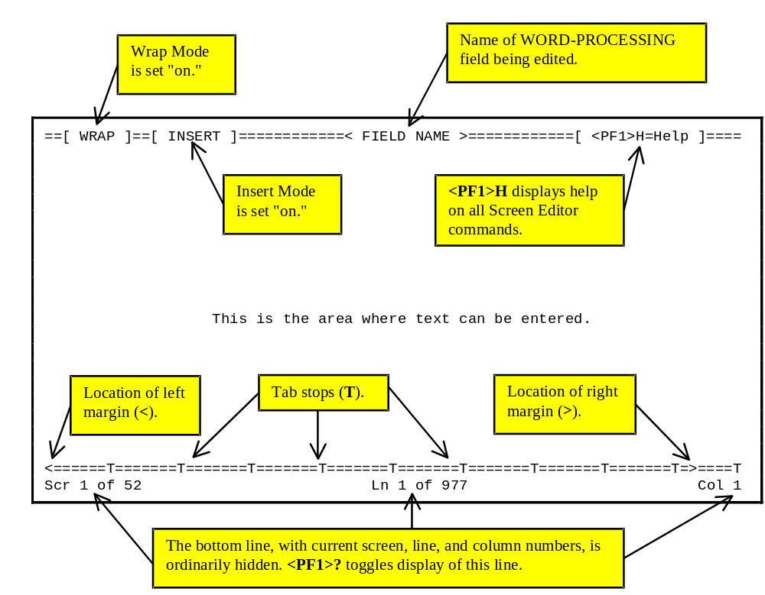
Figure 101: An Example of a WORD-PROCESSING Field in the Screen Editor

Entering Text

When using the Screen Editor, you type your text as you normally would. As you type, the Screen Editor automatically wraps lines of text to fit within the left and right margins. There is no need to press the Enter/Return key at the end of each line. The Screen Editor accepts any printable characters as keyboard input. However, it cannot be used to edit text that contains control characters.

Entering Commands

Editor commands are invoked using keyboard command sequences. The Screen Editor makes use of the <PF> keys, the cursor keypad, and, if available on the keyboard, the edit keypad to perform its editing functions.

Cursor Movement (Navigation Keystrokes)

The following table illustrates the keystrokes you use to navigate while in the Screen Editor:

Action | Key Sequence
Move one column left or right | <ArrowLeft> or <ArrowRight>
Move one line up or down | <ArrowUp> or <ArrowDown>
Move one word left or right | <Ctrl-J> or <Ctrl-L>
Move to next tab stop to the right | <Tab>
Move cursor left or right one screen | <PF1><ArrowLeft> or <PF1><ArrowRight>
Move cursor to beginning or end of line | <PF1><PF1><ArrowLeft> or <PF1><PF1><ArrowRight>  OR: <Find> or <Select>  OR: <Home> or <End>
Move cursor one screen up or down | <PF1><ArrowUp> or <PF1><ArrowDown>  OR: <PrevScreen> or <NextScreen>  OR: <Page Up> or <Page Down>
Move to top or bottom of document | <PF1>T or <PF1>B
Go to a specific screen, line, or column. | <PF1>G
Table 21: Keystrokes to Navigate in the Screen Editor

You can move forward quickly across a line by pressing the Tab key (<Tab>). The Tab key in the Screen Editor does not insert anything into the text. The Tab key is for navigation only and simply moves the cursor to the next tab stop to the right. Another way to move across a line, either forward or backward, is to move a word at a time, using <Ctrl-J> or <Ctrl-L>.

Saving and Exiting

The following table illustrates the keystrokes you use to exit and/or save text while in the Screen Editor:

Action | Key Sequence
Exit and save text | <PF1>E
Quit without saving | <PF1>Q
Exit, save, and switch editors | <PF1>A
Save without exiting | <PF1>S
Table 22: Keystrokes to Exit and/or Save Text in the Screen Editor

If your editing session ends unexpectedly because of hardware failure or another reason that prevents normal exiting, any changes you've made in the current WORD-PROCESSING field are not saved. On the other hand, if you time out when editing text, your changes are saved.

Finding Text

The following table illustrates the keystrokes you use to find text while in the Screen Editor:

Action | Key Sequence
Find text (not case sensitive) | <PF1>F  Brings up a "Find" dialogue (see picture below). To search for text downward, enter the text to find and press the Enter/Return key. To search for text upward, enter the text to find and press <ArrowUp>. \
Find next occurrence of text | <PF1>N
Find/Replace text | <PF1>P
Table 23: Keystrokes to Find Text in the Screen Editor

Figure 102: "FIND" Dialogue while Using the Screen Editor

Formatting Paragraphs

The following table illustrates the keystrokes you use to format paragraphs while in the Screen Editor:

Action | Key Sequence
Join and/or break the current line and next line | <PF1>J  Make sure Wrap mode is on before joining or breaking lines (Toggle Wrap mode with <PF2>).
Reformat paragraph | <PF1>R  Joins and/or breaks all lines between current line and next blank line, to create a word-wrapped paragraph. Make sure Wrap mode is on first (Toggle with <PF2>).  The reformat paragraph command is very useful!
Table 24: Keystrokes to Format Paragraphs in the Screen Editor

Cutting and Pasting

The following table illustrates the keystrokes you use to cut and paste text while in the Screen Editor:

Action | Key Sequence
Select/Mark text | <PF1>M  Position the cursor at the beginning of the text you wish to select and press <PF1>M. Move the cursor to the end of the text you want and press <PF1>M again. The selected text is highlighted in reverse video.
Deselect/Unmark text | <PF1><PF1>M
Delete selected text | <Delete> or <Backspace> on selected text
Cut and save to buffer | <PF1>X on selected text
Copy and save to buffer | <PF1>C on selected text
Paste from buffer | <PF1>V
Move text to another location | <PF1>X at new location
Copy text to another location | <PF1>C at new location
Table 25: Keystrokes to Cut and Paste Text in the Screen Editor

To move or copy selected text to another location:

1. Select the text (use <PF1>M).

2. Place the cursor at the new location.

3. Press <PF1>X (move text) or <PF1>C (copy text).

To save text to the buffer so that you can paste one or more times:

1. Select the text (use <PF1>M).

2. With the cursor on the selected text, press <PF1>X (cut text to buffer) or <PF1>C (copy text to buffer).

To paste text from the buffer:

1. Move the cursor to the location you want to paste the text.

2. Press <PF1>V.

Deleting

The following table illustrates the keystrokes you use to delete text while in the Screen Editor:

Action | Key Sequence
Character before cursor | <Backspace>
Character at cursor | <PF4> or <Remove> or <Delete>  (which key depends on your terminal and keyboard type)
Word at cursor | <Ctrl-W>
From cursor to end of line | <PF1><PF2>
Entire line | <PF1>D
Table 26: Keystrokes to Delete Text in the Screen Editor

Settings/Modes

The following table illustrates the keystrokes you use to change settings and mode while in the Screen Editor:

Action | Key Sequence
Wrap/No Wrap mode toggle | <PF2>  If wrap is off, left and right margin settings are ignored.
Insert/Replace mode toggle | <PF3> or <Insert Here> or <Insert>  Determines whether new characters are inserted before existing text, or instead overwrite existing text.
Set/Clear tab stop | <PF1><Tab>  Change from default tab stops is effective for current session only.
Set left margin | <PF1><Comma>  Move cursor to desired left margin position first.
Set right margin | <PF1><Period>  Move cursor to desired right margin position first.
Status line toggle (on or off) | <PF1>?
Table 27: Keystrokes to Change the Settings and Mode in the Screen Editor

Troubleshooting

Terminal Type Setting

The Screen Editor is designed for use on all terminal types known in the Kernel computing environment. It is very important that your terminal type be correctly identified to VA FileMan. Refer to the Kernel manuals for more information about how terminal types are identified. Since the <PF> keys are used in the Screen Editor, those keys should not be reprogrammed.

<PF> Keys Not Working: How to Exit

If your <PF> keys do not work in the Screen Editor, your terminal type is probably set incorrectly. Before you can correct the setting, you need to make an emergency exit from the editor by using one of the following keystroke combinations:
- Press <Esc>OPQ (if your keyboard has an Escape key).
- Press <Ctrl-[>OPQ (if your keyboard does not have an Escape key).
- Press <Ctrl-A>@<Enter>Q (if neither of the above methods work).

You must enter all letters in the above key sequences in uppercase.

Screen Editor and Personal Computers

Pasting and Uploading

If you are accessing your hospital computer system from a personal computer (PC), you can paste text from an application on the PC into the Screen Editor, and also upload files into the Screen Editor. There are some issues to be aware of when pasting text or uploading files into the Screen Editor.

Symbol Characters

Extended ASCII characters (typically "symbol" characters) cannot be stored in WORD-PROCESSING fields. Examples of such characters include "smart quote" characters, bullets, and symbols. Such characters, when encountered, are stripped or replaced with a space, ', ", or *, as appropriate. To avoid problems uploading these types of characters, you should:
- Turn off "smart quotes" in your word processor on your personal computer.
- Avoid using bullets.
- Avoid using symbols in your text such as: ¼, ½ , and º.

Files: Save as Text

If you are uploading an entire word processing document (as opposed to pasting), save it first as a "Text Only with Line Breaks" (or similar) file type in your personal computer word processor.

Wrap Vs. No Wrap

If your source document contains a carriage return at the end of every line, turn WRAP off in the Screen Editor before you paste or upload by pressing <PF2>. Turn it back on once the paste or upload is completed. If your source document contains a carriage return at the end of each paragraph only, however, leave WRAP on in the Screen Editor.

Avoiding Lost Characters

If the host computer system can't keep up with the your text upload, characters can get "lost." This can be a factor if you upload large quantities of text or characters. This character loss can occur because pastes and ASCII uploads don't use error-correcting communications protocols.

If you notice characters getting lost, one way to solve this is to adjust the "character pacing" (or similar) setting in your terminal emulation program. This can slow down the transfer of text such that characters no longer get lost due to communications overload.

If you need to paste or upload large quantities of text, consider switching to an Alternate Editor such as Kermit that uses an error-correcting communications protocol. This automatically compensates for communications overflows, preventing the loss of characters during text transfer. To use Kermit, it must be installed as an Alternate Editor at your site.

Line Editor

The Line Editor is a scrolling mode editor. It is the second of two standard editors VA FileMan provides for editing WORD-PROCESSING-type fields. The distinguishing characteristic of a Scrolling Mode editor is that you enter your text one line at a time, and that you can only edit lines one at a time. Because word processing in a scrolling mode interface can be cumbersome, you may want to set your Preferred Editor to the Screen Editor. VA FileMan continues to provide the Scrolling-Mode Line Editor, however, for those who prefer it.

To set your default editor, please refer to Chapter 9, "Choice of Word Processing Editors," in this manual.

For most people, the Screen Editor should be your Preferred Editor for WORD-PROCESSING fields.

Recognizing the Line Editor

When you edit a WORD-PROCESSING field, it's easy to see if VA FileMan chooses the Line Editor as your editor. If the Line Editor is used, the last nine lines of text (if there are that many) are displayed on the screen, with numbered prompts at the start of each line. Also, after the text is listed, you are prompted with "EDIT Option:". The "EDIT Option:" prompt is where you can enter each Line Editor command to work with the text.

For example:

HISTORY:
1>Owing to poverty in early youth, patient seems not to
2>have had proper diet. Since achieving economic success,
3>his diet has been adequate, but traces of original
4>deficiency remain.
5>
EDIT Option:
Figure 103: An Example of a WORD-PROCESSING Field in the Line Editor

How to Enter Text in the Line Editor

If no text exists yet in a WORD-PROCESSING field that you're about to edit, you'll see the field name followed by "1>". This is the Line Editor's prompt for entering word processing text.

For example:

Select PATIENT FILE NAME: FMPATIENT,FOUR
Select DIAGNOSIS: ANGINA PECTORIS// B-12 DEFICIENCY
HISTORY:
1>
Figure 104: Line Editor's Prompt for Entering Word Processing Text

You can now enter the text for Line 1 and press the Enter/Return key. This brings you to a prompt "2>" for Line 2, and so forth. Keep adding lines until you are done; then, press the Enter/Return key on a blank line to finish your edit, as shown below:

HISTORY:
1>Owing to poverty in early youth, patient seems not to<Enter>
2>have had proper diet. Since achieving economic success,<Enter>
3>his diet has been adequate, but traces of original<Enter>
4>deficiency remain.<Enter>
5><Enter>
EDIT Option: <Enter>

Select DIAGNOSIS:
Figure 105: Completing Your Edits in the Line Editor

Revising Existing Text

To revise the contents of the WORD-PROCESSING field, you need to call up each individual line that you want to edit and then edit each line. Here is how you can do this:

1. At the "EDIT Option:" prompt, enter the letter "E" for Edit a Line (Replace __ With __).

2. At the "Edit line:" prompt, enter the number of the line you need to revise.

3. Now, beneath the "EDIT Option:" and "Edit line:" prompts, you'll see the line of text that you identified by number and you'll see the "Replace" prompt.

4. Enter a string in the current line to be replaced.

5. If the string you enter is found in the current line, you'll set the "With" prompt. Enter a string to replace the original string.

6. The line is now updated, and you're asked for another string to replace. If you're done editing the line, simply press the Enter/Return key.

Shortcut: Enter Line Number to Edit at "EDIT Option:" Prompt

There's a shortcut to edit a particular line. At the "EDIT Option:" prompt, instead of choosing the Edit a Line (Replace __ With __) option and entering the line number, just enter the line number instead. You are taken directly to the line you specify, and then given the "Replace" prompt to edit the line:

EDIT Option: 5 <Enter>
5>was the time of the day that I wnet over to Building 8 and
Replace wnet With went Replace <Enter>
was the time of the day that I went over to Building 8 and
Edit line:
Figure 106: A Shortcut to Edit a Specific Line Using the Line Editor

"Replace...With" Edits: Be Careful

When editing individual lines, you make changes using the "Replace...With" dialogue, where you enter an existing string in the line, and a new string to replace it with. Be careful as you enter your responses to the "Replace" and "With" prompts. Enter enough letters to ensure that the computer replaces the desired string of characters.

Here's why this issue is so important. In one line, you may have two identical words or you may have two identical sets of characters embedded. Since the computer changes only the first occurrence of any series of letters that you enter, review your line carefully before responding to the "Replace" prompt. Then enter enough identifying characters to correct the specific word or characters you wish to change. Let's look at an incorrect entry to illustrate the point.

In the example that follows, you need to change the sentence in the second line from "This example is sample" to the sentence "This example is simple."

EDIT Option: 2 <Enter>
2>This example is sample
Replace ample With imple Replace <Enter>
This eximple is sample
Edit line:
Figure 107: An Example of an Incorrect Edit with the "Replace...With" Editor

As you can see from this example, VA FileMan replaced the first occurrence of the "ample" characters. Thus, "example" was changed to "eximple" rather than "sample" being changed to "simple" because the word "example" came before the word "simple" in the sentence (i.e., it was the first occurrence). Obviously, we should have replaced the whole word "sample" with "simple" to avoid any confusion.

Shortcuts at the "Replace...With" Prompt

As with editing long field values, you can replace long strings of characters by using ellipses. An ellipsis is three successive periods (...). When editing, you can replace longer strings of characters by using an ellipsis at the "Replace" prompt. You can specify ranges of text to replace for any line (just as with a long text field) with the ellipsis.

For example, to replace an entire line at a "Replace...With" prompt, enter the ellipsis (three periods) at the "Replace" prompt. You are then able to replace the entire default with what you entered at the "With" prompt:

EDIT Option: 5 <Enter>
5>care of the boxes.
Replace ... With care to replace the existing supplies. Replace <Enter>
care to replace the existing supplies.
Edit line:
Figure 108: Using the Ellipsis to Replace an Entire Line

"Replace..." Prompt Shortcuts

The table below lists valid shortcut you can use in the "Replace...With" editor:

Shortcut | Action
... | Replaces everything.
xxx... | Replaces everything starting from the characters "xxx" to the end. <PF1>E
...xxx | Replaces everything from the beginning up to and including the characters "xxx." <PF1>Q
xxx...yyy | Replaces everything starting from "xxx" up to and including "yyy." <PF1>A
end or END | Appends what you enter at the "With" prompt to the end of the value. <PF1>S
Table 28: "Replace" Prompt Shortcuts

Commands

Available Commands

In the Line Editor, all commands are available at the "EDIT Option:" prompt. To see a list of available commands, simply enter two question marks, as shown below:

EDIT Option: ??
Choose, by first letter, a Word Processing Command from the following:
Add Lines to End of Text
Break a Line into Two
Change Every String to Another in a Range of Lines
Delete Line(s)
Edit a Line (Replace __ With __)
Insert Line(s) after an Existing Line
Join Line to the One Following
List a Range of Lines
Move Lines to New Location within Text
Print Lines as Formatted Output
Repeat Lines at a New Location
Search for a String
Transfer Lines From Another Document
Utility Sub-Menu
Y-Programmer Edit
or type a Line Number to edit that line.
EDIT Option: Utilities in Word-Processing
UTILITY Option: ??
Choose, by first letter, a Utility Command from the following:
Editor Change
File Transfer from Foreign CPU
Text-Terminator-String Change
UTILITY Option:
Figure 109: Edit Options Available with the Line Editor

LIST: List the Message

Assume that you've just entered four lines of text in a WORD-PROCESSING field and would now like to review the entire text. After entering text on Line 4 (4>), press the Enter/Return key. When prompted for Line 5 (5>), press the Enter/Return key again and you'll arrive at the "EDIT Option:" prompt. Enter "L" (for List a Range of Lines option) and choose the range of lines to list (in this case, Lines 1 to 4):

EDIT Option: L <Enter> ist line: 1// <Enter> to: 4// <Enter>
1>Owing to poverty in early youth, patient seems not to
2>have had proper diet. Since achieving economic success,
3>his diet has been adequate, but traces of original
4>deficiency remain.
EDIT Option:
Figure 110: An Example Using the List a Range of Lines Option

ADD: Append More Text

After listing lines of text (see above), suppose you need to add a few comments at the end of your message. From the "EDIT Option:" prompt, enter "A" (for Add Lines to End of Text option). You can now add additional lines:

EDIT Option: A <Enter> dd lines
6> Next appointment will be in three weeks.
7> Regular appointments need to be set up.
8> <Enter>
Figure 111: An Example Using the Add Lines to End of Text Option

JOIN: Combine Two Lines of Text

Suppose you're at the "EDIT Option:" prompt. After briefly reviewing your text, you've decided that Lines 4 and 5 (4> and 5>) are too short. You can use the Join command (i.e., Join Line to the One Following option) to join Line 4 to the next line:

EDIT Option: L <Enter> ist line: 2// <Enter> to: 3// <Enter>
2>left by
3>the doorway.
EDIT Option: J <Enter> oin line: 2 <Enter>
2>left by the doorway.
..
EDIT Option:
Figure 112: An Example Using the Join Line to the One Following Option

INSERT: Insert New Line(s) of Text Between Existing Ones

Suppose that you want to insert new lines of text in the middle of existing text in a WORD-PROCESSING field. Using the Add Lines to End of Text won't work, because that appends new text lines at the end of the existing lines. Instead, you can use the Insert command [i.e., Insert Line(s) after an Existing Line option], to do this:

EDIT Option: L <Enter> ist line: 1// <Enter> to: 5// <Enter>
1>The delivery people came, and left several packages
2>by the doorway.
3>We've got some work ahead of us now.
EDIT Option: I <Enter> nsert after line: 2 <Enter>
3> <Enter>
4> Finally, the order arrived! <Enter>
5> <Enter>
Figure 113: An Example Using the Insert Line(s) after an Existing Line Option

DELETE: Delete a Line or Lines

Occasionally, you may need to delete lines of text in a WORD-PROCESSING field. Use the Delete command [i.e., Delete Line(s) option] at the "EDIT Option:" prompt to do this:

EDIT Option: D <Enter> elete from line: 5 <Enter> thru: 3// 6
<Enter>
OK TO REMOVE 2 LINES? No// Y <Enter> (Yes).....
1>The delivery people came, and left several packages
2>by the doorway.
3>
4>Finally, the order arrived!
EDIT Option:
Figure 114: An Example Using the Delete Line(s) Option

Advanced Features

Most of the features of the Line Editor are self-explanatory and simple to use. However, a few require additional explanation, as follows in this chapter.

To see a full list of the commands available at the "EDIT Option:" prompt, enter two question marks (??), as shown in Figure 109.

File Transfer (Use When Uploading ASCII Text)

The File Transfer from Foreign CPU option from the Utility Sub-Menu lets you upload text from another system into your WORD-PROCESSING field text, using an ASCII (non-error-correcting) transfer. For example, if you are connected from a personal computer (PC), you can use your communication software to send a text file.

The file to be transferred must be a text (pure ASCII) file. Most word processing programs have a way of saving a document as text (i.e., without special formatting information); check your word processor's manual. Also, you need to know how to send a text file using your PC's communication software; if you're not sure how, check your communications software manual.

To use the File Transfer from Foreign CPU option:
- Make sure the file you're transferring is a pure ASCII text file.
- While editing a WORD-PROCESSING field in the Line Editor, choose the Utility Sub-Menu option at the "EDIT Option:" prompt. Then choose the File Transfer from Foreign CPU option from the Utility Sub-Menu.
- At the "MAXIMUM string length? : (3-245):" prompt, enter maximum string length for lines you are uploading.
- The Line Editor now waits up to 30 seconds for you to initiate an ASCII transfer of the file.
- Use your communications software to perform an ASCII upload of the file. All uploaded text is appended to the WORD-PROCESSING field that you are editing.
- Once you have finished uploading, it takes 30 seconds of inactivity until the transfer can complete. When done, and after 30 seconds of inactivity, the computer responds "FILE TRANSFER COMPLETE" and you are returned to the "EDIT Option:" prompt.

The same precautions apply for uploading large quantities of text to the Line Editor as apply with the Screen Editor. In particular, if you need to upload large quantities of text quickly, consider switching to an Alternate Editor such as Kermit (if installed as an Alternate Editor by your site) which provides error-correcting communications protocol. Unlike an ASCII transfer (used with the File Transfer option), an error-correcting protocol such as Kermit can transfer text and automatically compensate for any communications overflows, without losing characters.

Text Terminator-String Change
(Use When Uploading Text with Blank Lines)

In the Line Editor, a blank line (null string) signals the end of data entry (and returns you to the "EDIT Option:" prompt. Thus, if you plan to paste or upload text into the Line Editor from a personal computer, any blank lines in the uploaded text have the side effect of signaling the end of data entry (prematurely). One way around this is to use the File Transfer from Foreign CPU option (see above). Another way around this problem is to use the Text-Terminator-String Change option on the Utility Sub-Menu. This lets you change the text terminator so that some character string, rather than a blank line, is what is used to signal the end of data entry.

You can change the text terminator to any string of between one and five characters; question marks (?) or carets ("^") are not allowed in the string. To finish editing a WORD-PROCESSING field and get to the "EDIT Option:" prompt, simply enter your new text terminator string instead of pressing the Enter/Return key on a blank line. You should choose a text terminator that doesn't appear in your text: "end" would not be a good choice, but "EnD" might be.

The new text terminator is not permanent; it remains only as long as you are editing a particular WORD-PROCESSING field. You can change it back to a null line by entering an at-sign (@) at the "Text-Terminator:" prompt. You can permanently change your default text terminator by changing it in your user characteristics as described in the Kernel manuals.

Programmer Edit (Edit Lines with M Commands)

The Y-Programmer Edit option (invoked by entering the letter Y) is only available to users with programmer's access. You can enter a line of M code that, line-by-line, reads in the current line in variable X and returns the transformed line in variable Y. You can specify the range of lines to be transformed by the M code you enter.

For example, to blank out all lines containing the words "Top Secret", you could enter the following M code:

EDIT Option: Y

The text is in X and returned in Y
Enter MUMPS xecute string to do transformation: I X["Top Secret" S Y=" "
Figure 115: An Example of Entering M Code while Using the Y-Programmer Edit Option

Editor Change: Switch Editors

The Editor Change option, on the Utility Sub-Menu, shows you a list of the editors available for your use, if you enter two question marks (??) at the "Select ALTERNATE EDITOR:" prompt. The editors include VA FileMan's own editors (the Line Editor and Screen Editor) and any other editors to which you have access. You choose the editor to use by entering its name. When you exit your chosen editor, you return to the Line Editor's "EDIT option:" prompt.

Transfer Text (from Another WORD-PROCESSING Field)

The Transfer Lines From Another Document option lets you copy text from some other WORD-PROCESSING field into your current field. You need to specify on which line of the current field to place the incoming text and identify the source of the text.

To identify the source of the text, you need to use extended pointer syntax, which is described in the "Relational Navigation" chapter of the VA FileMan Advanced User Manual. The syntax lets you specify the particular field of a specific entry in a specific file. Briefly, the syntax can be in one of the following two forms:

<expression>:<file>:<field>

OR

<expression> IN <file> FILE:<field>

The <expression> or lookup value has several possible forms. One way to refer to the field is by entry name. To retrieve text from the WORD-PROCESSING PROGNOSIS field of the entry Angina Pectoris in a file named DIAGNOSES, you could enter the following:

EDIT Option: T <Enter> ransfer incoming text after line: 1 <Enter>
From what text: ? <Enter>

Select another entry in this file, OR
use relational syntax to pick up information from a word-
processing field in another file.
ex. "VALUE":FILE NAME:WORD PROCESSING FIELD NAME

Do you want the entire TEST list?
Enter Yes or No: ^
From what text: "Angina Pectoris":DIAGNOSES:PROGNOSIS <Enter>
From line: 1 <Enter> thru: 20 <Enter>
ARE YOU SURE? NO// y <Enter> (YES)... . .
Figure 116: Example #1 of Extended Pointer Syntax while Using the Transfer Lines From Another Document Option

Alternately, you can use the second syntax to retrieve the same field in the same file entry:

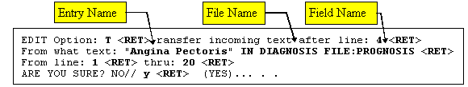
Figure 117: Example #2 of Extended Pointer Syntax while Using the Transfer Lines From Another Document Option

The requested text is identified by the value of the .01 field in quotes ("Angina Pectoris"). Thus, in this example the <expression> is the entry's name. You also specify which lines you want to transfer. If you enter a single question mark (?) at the "From line:" prompt, you can list the current numbered lines in the WORD-PROCESSING field. You can then easily choose the lines to be transferred.

If the field from which you are transferring text displays text without wrapping, you'll receive the following message:

WARNING!
The field you are transferring text from displays text without wrapping.
The field you are transferring text into may display text differently.

Do you want to continue?

Enter Yes or No:
Figure 118: An Example of a Possible Warning Message when Using the Transfer Lines From Another Document Option

Consider the possibility that the text transferred from the no-wrap field may be unreadable, if the field you are transferring into does wrap text. For example, a spreadsheet might lose the alignment of its columns.

If the transfer does not succeed, the message <no change> is shown. The transfer might fail for several reasons:
- Incorrect syntax for the extended pointer.
- An attempted transfer from other than a WORD-PROCESSING DATA TYPE field.
- Lack of permission to read the file from which you are trying to extract text.

You must have READ ACCESS to transfer text from a file.

For details of the different types of file security, please refer to the "Data Security" chapter in the VA FileMan Advanced User Manual.

Glossary

You can also search the Free Online Dictionary of Computing.

.001 Field | A field containing the internal entry number of the record.
.01 Field | The one field that must be present for every file and file entry. It is also called the NAME field. At a file's creation the .01 field is given the label NAME. This label can be changed.
Access Codes | In VA FileMan, a string of codes that determines your security access to files, fields, and templates. In Kernel, you enter an Access Code to identify yourself during signon.
Alternate Editor | One of the text editors available for use from VA FileMan. Editors available vary from site to site. They are entries in the ALTERNATE EDITOR file (#1.2).
At-sign (@) | A VA FileMan security Access Code that gives the user programmer-level access to files and to VA FileMan's developer features. See Programmer Access. Also, the character "@" (i.e., at-sign) is used at VA FileMan field prompts to delete data.
  Programmer access in VistA is defined as DUZ(0)="@". It grants the privilege to become a programmer in VistA. Programmer access allows you to work outside many of the security controls enforced by VA FileMan, enables access to all VA FileMan files, access to modify data dictionaries, etc. It is important to proceed with caution when having access to the system in this way.
Audit Trail | The record or log of an ongoing audit.
Auditing | The monitoring and recording of computer use.
Backward Pointer | A pointer to your current file from another file; used in the extended pointer syntax.
Boolean Expression | A logical comparison between values yielding a true or false result. In M, zero means false and non-zero (often one) means true.
Canonic Number | A number with no leading zeros and no trailing zeros after a decimal point.
Caption | In ScreenMan, a label displayed on the screen. Captions often identify fields that are to be edited.
Command Area | In ScreenMan, the bottom portion of the screen used to display help information and to accept user commands.
Cross-reference | An attribute of a field or a file that identifies an action that should take place when the value of a field is changed. Often, the action is the placement of the field's value into an index. A Traditional cross-reference is defined with a specific field. A New-Style cross-reference is a file attribute and can be composed of one or more fields. New-Style cross-references are stored in the INDEX file (#.11).
Cursor | On your display terminal, the line or rectangle identifying where your next input will be placed on the screen.
Data Dictionary | A record of a file's structure, its elements (fields and their attributes), and relationships to other files. Often abbreviated as DD.
DATA TYPE | The kind of data stored in a field. NUMERIC, COMPUTED, and WORD-PROCESSING are examples of VA FileMan DATA TYPEs.
Database | An organized collection of data spanning many files. Often, all the files on a system constitute that system's database.
Decentralized Hospital Computer Program (DHCP) | See VISTA.
Default | A computer-provided response to a question or prompt. The default might be a value pre-existing in a file. Often, you can change a default.
Device Prompt | A Kernel prompt at which you identify where to send your output.
Edit Window | In ScreenMan, the area in which you enter or edit data. It is highlighted with either reverse video or an underline. In Screen Editor, the area in which you enter and edit text; the area between the status bar and the ruler.
Entry | A record in a file. "Entry" and "record" are used interchangeably.
Extended Pointers | A means to reference fields in files other than your current file.
Field | In an entry, a specified area used to hold values. The specifications of each VA FileMan field are documented in the file's data dictionary.
Field Number | The unique number used to identify a field in a file. A field can be referenced by "#" followed by the field number.
File | A set of related records (or entries) treated as a unit.
Form | In ScreenMan, a group of one or more pages that comprise a complete transaction. Comparable to an INPUT template.
FREE TEXT | A DATA TYPE that can contain any printable characters.
Full-screen Editing | The ability to enter data in various locations on the two-dimensional computer display. Compare to scrolling mode.
Histogram | A type of bar graph that indicates frequency of occurrence of particular values.
Identifier | In VA FileMan, a field that is defined to aid in identifying an entry in conjunction with the NAME field.
Index | An ordered list used to speed retrieval of entries from a file based on a value in some field or fields. The term "simple index" refers to an index that stores the data for a single field; the term "compound index" refers to an index that stores the data for more than one field. Indexes are created and maintained via cross-references.
INPUT Template | A pre-defined list of fields that together comprise an editing session.
Internal Entry Number | The number used to identify an entry within a file. Every record has a unique internal entry number. Often abbreviated as IEN.
Kernel | A VISTA software package that functions as an intermediary between the host operating system and VISTA application packages. Kernel includes installation, menu, security, and device services.
Key | A group of fields that, taken collectively, uniquely identifies a record in a file or subfile. All fields in a key must have values. The term "simple key" refers to keys that are composed of only one field; the term "compound key" refers to keys that are composed of more than one field. Keys are stored in the KEY file (#.31)
LAYGO | A user's authorization to create a new entry when editing a computer file. An acronym for Learn As You Go.
Line Editor | The VA FileMan editor that lets you input and change text on a line-by-line basis. The Line Editor works in scrolling mode. See Screen Editor.
Lookup | To find an entry in a file using a value for one of its fields.
MailMan | An electronic mail system (e-mail) that allows you to send messages to and receive them from other users via the computer. It is part of VISTA.
Menu | A list that includes the names of options from which you can select an activity.
Multiple | A VA FileMan DATA TYPE that allows more than one value for a single entry. See Subfile.
MUMPS | Abbreviated as M. The American National Standards Institute (ANSI) computer language used by VA FileMan and throughout VISTA. The acronym MUMPS stands for Massachusetts General Hospital Utility Multi Programming System.
NAME Field | The one field that must be present for every file and file entry. It is also called the .01 field. At a file's creation the .01 field is given the label NAME. This label can be changed.
Navigation | 1. Navigation can mean switching your reference point from one file to another.  2. Navigation can also mean moving your cursor around a terminal display or a document using cursor keys and other commands.
Non-canonic Number | A number with either leading zeros, or trailing zeros after a decimal point. M treats non-canonic numbers as text instead of as numbers.
Non-null | A value other than null. A space and zero are non-null values.
Null | Empty. A field or variable that has no value associated with it is null.
Null Response | When replying to a prompt, pressing only the Enter/Return key, abbreviated as <Enter>, to enter nothing.
Numeric Expression | An expression whose value is a number. Compare to string expression.
Operator | One of the processes done to the elements in an expression to create a value.
Option | A computing activity that you can select, usually a choice from a menu.
Paste | Insert text or other data as input into one computer program that has been copied into a clipboard by the same or by another computer program.
Pattern Match | In M, an operator that compares the contents of a variable or literal to a specified pattern of characters or kinds of characters.
PF keys | Keys on a terminal keyboard labeled PF1, PF2, etc. that are used to perform special functions instead of displaying visible characters.
POINTER TO A FILE | A field DATA TYPE that contains an explicit reference to an entry in a file. POINTER TO A FILE-type fields are used to relate files to each other.
Pop-up Page | In ScreenMan, a page that overlays the regular ScreenMan screen in order to present the contents of a selected Multiple.
Preferred Editor | The editor always entered when you access a WORD-PROCESSING-type field; your default editor. Kernel must be present to establish a Preferred Editor.
PRINT Template | The stored specifications of a printed report, including fields to be printed and formatting instructions.
Programmer Access | The ability to use VA FileMan features that are reserved for application developers. Referred to as "having the at-sign ('@')" because the at-sign is the DUZ(0) value that grants programmer access.
  Programmer access in VistA is defined as DUZ(0)="@". It grants the privilege to become a programmer in VistA. Programmer access allows you to work outside many of the security controls enforced by VA FileMan, enables access to all VA FileMan files, access to modify data dictionaries, etc. It is important to proceed with caution when having access to the system in this way.
Prompt | A question or message from the computer requiring your response.
Record | A set of data pertaining to a single entity in a file; an entry in a file.
Record Number | See Internal Entry Number.
Relational Navigation | Changing your current (or primary) file reference to another file. Relational navigation is accomplished by using the extended pointer syntax without specifying a field in the referenced file.
Required Field | A field that cannot be left null for an entry.
Scattergram | A graph in which occurrences of two fields are displayed on an X-Y coordinate grid to aid in data analysis.
Screen Editor | VA FileMan's Screen-oriented text editor. It can be used to enter data into any WORD-PROCESSING field using full-screen editing instead of line-by-line editing. See Line Editor.
Screen-oriented | A computer interface in which you see many lines of data at a time and in which you can move your cursor around the display screen using screen navigation commands. Compare to Scrolling Mode.
ScreenMan | The set of routines that supports Screen-oriented data editing and data display.
Scrolling Mode | The presentation of the interactive dialogue one line at a time. Compare to Screen-oriented.
SDP | An area on disk set aside for temporary, sequential storage of data; an abbreviation for Sequential Disk Processor. It is available on some M implementations (e.g., DSM-11).
SEARCH Template | The saved results of a search operation. Usually, the actual entries found are stored in addition to the criteria used to select those entries.
Security | The strategies and procedures used to ensure that user access to data and data structures is controlled and appropriate.
SET OF CODES | A field DATA TYPE where a short character string is defined to represent a longer value.
Simple Extended Pointers | An extended pointer that uses a pre-existing pointer relationship to access entries in another file.
Sort | To place items in order, often in alphabetical or numeric sequence.
SORT Template | The stored record of sort specifications. It contains sorting order as well as restrictions on the selection of entries. Used to prepare entries for printing.
Stuff | To place values directly into a field, usually with no user interaction.
Subentry | An entry in a Multiple; also called a Subrecord.
Subfield | A field in a Multiple.
Subfile | The data structure of a Multiple. In many respects, a Subfile has the same characteristics as a File.
Terminal Emulation | Using one kind of terminal or computer display to mimic another kind. Often used with PC remote communication applications.
Terminal Type | The designation of the kind of computer peripheral being used (e.g., the kind of video display or printer). Full terminal type functionality is supplied by Kernel.
Truth Test | An evaluation of an expression yielding a true or false result. In M, usually a 1 (true) or a 0 (false) is returned from a truth test.
Caret | The ^ character (caret); used in VA FileMan for exiting an option or canceling a response. Also used in combination with a field name or prompt to jump to the specified field or prompt.
Upload | Send a file from one computer system to another (usually using communications software).
VISTA | The Veterans Health Information Systems and Technology Architecture (VISTA), within the Department of Veterans Affairs, is the component of the Veterans Health Administration that develops software and installs, maintains, and updates compatible computer systems in VA medical facilities. (Previously known as the Decentralized Hospital Computer Program [DHCP].)

Index

A
Abbreviations
Dates, 6-2
Times, 6-4
Acceptable Formats for Entering
Dates, 6-2
Times, 6-3
Access
LAYGO, 5
Add (Append) More Text (Line Editor), 11-6
Add a Record at a POINTER TO A FILE Field, How to, 7-4
Add a Record, How to, 7-1
Add Lines to End of Text Option, 11-6
Adding
From Multiples, 7-6
Records, 7-1
Adding a
Duplicate Record, 7-2
Duplicate-Named Entry, 7-5
New Entry to a Multiple
ScreenMan, 8-10
Advanced Features
Line Editor, 11-8
At-sign
Deleting
Field's Value, 5-9
File/Record Entry, 7-1, 7-2
Multiple Entry, 7-6
Subrecord, 8-9
Template, 2-21
Text at the Replace... prompt, 5-6
Text Terminator, 11-9
Entering Times, 6-3
Including Null Records in a Report, 2-6
Omit Headers and Page Feeds from Printed Output, 2-27
Omit Headers from Printed Output, 2-26
Suppressing Subheaders, 2-9
Avoiding Lost Characters
Screen Editor, 10-11
B
Browser, 4-1
As an Option, 4-7
Clipboard, 4-4
Cursor Movement (Navigation Keystrokes), 4-3
Features, 4-2
Navigation Keystrokes, 4-3
Online Help, 4-5
Other Features, 4-6
Screen, 4-1
Search, 4-5
C
Capabilities When Printing, 2-1
CAPTIONED OUTPUT, 1-3
COMPUTED Fields and Record Numbers, 2-23
Template, 6-8
CAPTIONED PRINT Template, 2-23, 6-8
Characters Lost, Avoiding
Screen Editor, 10-11
Choose Your Own
Device, 1-4
Print Fields, 1-4, 2-14
Word Processing Editors, 9-1
Clipboard
Browser, 4-4
Column Format for VA FileMan Prints, 2-2
Commands
Available with the Line Editor, 11-5
ScreenMan Command Line Options:, 8-5
Compound Key, 5-8
COMPUTED DATA TYPE Fields, 6-8
Including, 1-3
COMPUTED Fields and Record Numbers in CAPTIONED OUTPUT, 2-23
Conditions
Combining in a Search, 3-4
Entering in a Search, 3-2
Tests in a Search, 3-2
Creating
PRINT Templates, 2-19
SEARCH Templates, 3-8
SORT Templates, 1-3, 2-12
Criteria, Saving in
PRINT Templates, 2-19
SEARCH Templates, 3-8
SORT Templates, 2-12
Cursor Movement (Navigation Keystrokes)
Browser, 4-3
Screen Editor, 10-4
ScreenMan, 8-3, 8-6
Custom Footers, 2-28
Custom Headings and Footers, 2-27
Cutting and Pasting
Screen Editor, 10-7
D
Data Entry Session (Typical Example), 5-12
DATA TYPEs of Fields, 6-1
COMPUTED, 6-8
DATE/TIME, 6-1
FREE TEXT, 6-5
Multiples (Subfiles), 6-11
NUMERIC, 6-4
POINTER TO A FILE, 6-8
SET OF CODES, 6-4
Subfiles (Multiples), 6-11
VARIABLE-POINTER, 6-10
WORD-PROCESSING, 6-6
Database and Files, 3
DATE/TIME DATA TYPE Fields, 6-1
Dates
Abbreviations, 6-2
Acceptable Formats, 6-2
Default Responses, 5-4
Default Responses (Longer), 5-5
Delete Line(s) Option, 11-7
Deleting
A Field's Value with the at-sign, 5-9
A Multiple (Subfile) Entry in ScreenMan, 8-9
From Multiples, 7-6
How to Delete a Record, 7-2
Lines of Text in the Line Editor, 11-7
Records, 7-1
Screen Editor, 10-8
ScreenMan, 8-7
Details
ScreenMan, 8-13
Search, 3-8
Devices, Choose Your Own, 1-4
Differences from Scrolling Mode Editing
ScreenMan, 8-1
DISPLAY AUDIT TRAIL Prompt, 1-3
Displaying Information, I-1
Documentation Symbols, x
Duplicates
Adding a
Duplicate Record, 7-2
Duplicate-Named Entry, 7-5
E
Edit a Line (Replace __ With __) option, 11-2
Edit Fields
How to do it in ScreenMan, 8-6
Edit Lines with M Commands
Line Editor, 11-9
Edit User Characteristics Option, 9-1
Editing
Records, II-1
ScreenMan, 8-6
Editor Change Option, 11-9
Editors
Change (Switch) Editors
Line Editor, 11-9
Choice of Word Processing Editors, 9-1
Line Editor, 11-1
Replace...With, 5-5, 6-1, 11-3, 11-4
Screen Editor, 10-1
Select Your Preferred Editor, 9-1
Switch (Change) Editors
Line Editor, 11-9
Switching to Another Editor While Editing, 9-1
WORD-PROCESSING Fields, 6-6
Zoom Editor in ScreenMan, 8-7
Edits
Edit User Characteristics Option, 9-1
How to File in ScreenMan, 8-13
Ellipsis, 11-3
Enter or Edit File Entries Option, 7-7
Enter/Return Key (<Enter>), 5-1
Entering
Commands in the Screen Editor, 10-3
Text in the
Line Editor, 11-1
Screen Editor, 10-3
Example
Data Entry Session (Typical), 5-12
Exiting
Screen Editor, 10-5
ScreenMan, 8-4
From a Subpage:, 8-9
With the Up-Arrow, 5-10
External vs. Internal Field Values
Search Conditions, 3-9
SET OF CODES, 6-5
F
Features
Browser, 4-2
Line Editor Advanced Features, 11-8
Other Features of the Browser, 4-6
Other Print Features, 2-24
Search, 3-8
Field Prompts
Special Responses to, 5-9
Fields
.01 Field, 7-1
Choosing Fields to Print, 2-14
DATA TYPEs, 6-1
COMPUTED, 6-8
DATE/TIME, 6-1
FREE TEXT, 6-5
Multiples (Subfiles), 6-11
NUMERIC, 6-4
POINTER TO A FILE, 6-8
SET OF CODES, 6-4
Subfiles (Multiples), 6-11
VARIABLE-POINTER, 6-10
WORD-PROCESSING, 6-6
Deleting a Field's Value, 5-9
Jumping to Another Field, 5-9
Mandatory (Required), 5-10
Required (Mandatory), 5-10
Fields, Records, and Files, 2
File Access
LAYGO, 5
File Edits
How to do it in ScreenMan, 8-13
File Transfer from Foreign CPU Option, 11-8
Line Editor, 11-8
FileMan
Prompts, 5-1
What is it?, 1
Files and the Database, 3
Files, Save as Text
Screen Editor, 10-11
Finding Text
Screen Editor, 10-5
Footers
Customized, 2-27, 2-28
Forcing Creation of a
PRINT Template, 2-21
SORT Template, 2-12
Format
Output in a Search, 3-6
Paragraphs in the Screen Editor, 10-6
FREE TEXT DATA TYPE Fields, 6-5
G
Getting Online Help at Any Prompt, 5-3
Glossary, 1
H
Headings
Customized, 2-27
Help
Getting Online Help at Any Prompt, 5-3
How to
Add a Record, 7-1
Add a Record at a POINTER TO A FILE Field, 7-4
Delete a Record, 7-2
Edit Fields
ScreenMan, 8-6
Enter Text in the Line Editor, 11-1
Exit the Screen Editor When PF Keys Not Working, 10-10
File Edits
ScreenMan, 8-13
Navigate Between Fields
ScreenMan, 8-3
Navigate Between Pages
ScreenMan, 8-4
Print Reports from Files, 2-1
Revise Existing Text in the Line Editor, 11-2
Search, 3-1
Select Your Preferred Editor, 9-1
Use this Manual, ix
HTML Manuals, v
I
Include COMPUTED Fields Prompt, 1-3
Incorrect Responses, 5-4
Information
Displaying, I-1
Inquire, 1-1
CAPTIONED OUTPUT, 1-3
Inquire to File Entries Option, 1-1, 2-1
Insert Line(s) after an Existing Line Option, 11-7
Insert New Lines of Text (Line Editor), 11-7
Installation, ix
Internal vs. External Field Values
Search Conditions, 3-9
SET OF CODES, 6-5
Introduction, 1
J
Join (Combine) Two Lines of Text (Line Editor), 11-6
Join Line to the One Following Option, 11-6
Jumping to Another Field with the up-arrow, 5-9
K
KERNEL SYSTEM PARAMETERS file, 2-25
Key Fields, 5-8
L
LAYGO File Access, 5
Line Editor, 11-1
Add (Append) More Text, 11-6
Add Lines to End of Text Option, 11-6
Advanced Features, 11-8
Change (Switch) Editors, 11-9
Commands, 11-5
Delete Line(s) Option, 11-7
Deleting Lines of Text, 11-7
Edit Lines with M Commands, 11-9
Editor Change Option, 11-9
Entering Text, 11-1
File Transfer from Foreign CPU Option, 11-8
Insert Line(s) after an Existing Line Option, 11-7
Insert New Lines of Text, 11-7
Join (Combine) Two Lines of Text, 11-6
Join Line to the One Following Option, 11-6
List a Range of Lines Option, 11-5
List the Message, 11-5
Programmer Edit, 11-9
Recognizing, 11-1
Revising Text, 11-2
Shortcuts, 11-2
Switch (Change) Editors, 11-9
Text-Terminator-String Change Option, 11-9
Transfer Lines From Another Document Option, 11-10
Transfer Text (from Another WORD-PROCESSING Field), 11-10
Uploading Text with Blank Lines, 11-9
Y-Programmer Edit Option, 11-9
List a Range of Lines Option, 11-5
List of Choices Prompts, 5-7
List the Message (Line Editor), 11-5
Long Fields
ScreenMan, 8-7
Longer Default Responses, 5-5
M
Mandatory (Required) Fields, 5-10
Manuals
In HTML Format, v
Modes
Screen Editor, 10-9
ScreenMan, 8-7
Scrolling Mode vs. Screen Mode, 5
Multiple Copies of a Print, 2-25
Multiples (Subfiles)
Adding a
New Entry in ScreenMan, 8-10
Adding and Deleting from, 7-6
DATA TYPE Fields, 6-11
DATA TYPEs Fields
Adding and Deleting from, 7-6
Deleting an Entry in ScreenMan, 8-9
In Repeating Blocks in ScreenMan, 8-10
Linked to "Pop-Up" Subpages in ScreenMan, 8-8
ScreenMan, 8-8
Searching for, 3-10
N
Navigate Between
Fields
How to do it in ScreenMan, 8-3
Pages
How to do it in ScreenMan, 8-4
Navigation Keystrokes
Browser, 4-3
Screen Editor, 10-4
ScreenMan, 8-3
Navigational Keys for Repeating Blocks
ScreenMan, 8-12
Null Fields in Your Sort, 2-6
Numbers
Canonic Numbers and Non-Canonic Strings, 2-4
NUMERIC DATA TYPE Fields, 6-4
O
Online Help
Browser, 4-5
Operators for Combining Search Conditions, 3-4
Options
Add Lines to End of Text, 11-6
Browser, 4-7
Delete Line(s), 11-7
Edit a Line (Replace __ With __), 11-2
Edit User Characteristics, 9-1
Editor Change, 11-9
Enter or Edit File Entries, 7-7
File Transfer from Foreign CPU, 11-8
Inquire to File Entries, 1-1, 2-1
Insert Line(s) after an Existing Line, 11-7
Join Line to the One Following, 11-6
List a Range of Lines, 11-5
Print File Entries, 2-1
Text-Terminator-String Change, 11-9
Transfer Lines From Another Document, 11-10
Y-Programmer Edit, 11-9
Order When Sorting, 2-4
Orientation for VA FileMan Getting Started Manual, ix
Other Features
Browser, 4-6
Print, 2-24
Output
Format in a Search, 3-6
P
Partial Responses, 5-4
Pasting and Cutting
Screen Editor, 10-7
Pasting and Uploading
Screen Editor, 10-11
patient & user names
test data, ix
Personal Computers and the Screen Editor, 10-11
PF Keys Not Working, How to Exit in the Screen Editor, 10-10
POINTER TO A FILE DATA TYPE Fields, 6-8
Preface, v
PREFERRED EDITOR Prompt, 9-1
Print, 2-1
Capabilities, 2-1
CAPTIONED PRINT Template, 2-23
Choosing Fields to Print, 2-14
Custom Footers, 2-28
Custom Headings and Footers, 2-27
Forcing Creation of a PRINT Template, 2-21
Including Null Fields in Your Sort, 2-6
Inserting Multiple-type Print Fields, 2-22
Multiple Copies, 2-25
Other Features, 2-24
PRINT FIELD Prompts, 2-16
Print File Entries Option, 2-1
Qualifiers, 2-15
Report Headings, 2-25
Reports from Files, How to, 2-1
Saving Criteria in PRINT Templates, 2-19
Selecting Entries
All Entries with the Same Value for One Field to Print, 2-5
For Printing, 2-5
Other Ways to Print, 2-5
SORT BY Fields, 2-27
Prompts, 2-8
Specifying, 2-3
Sorting, 2-3
Order, 2-4
Print Sort Criteria in the Heading or the Footer, 2-28
Qualifiers, 2-8
Specifying Fields to Print, 2-14
Specifying SORT BY Fields, 2-3
Standard Column Format, 2-2
Statistics Only, 2-24
Suppressing Report Headings (and Page Feeds), 2-26
Templates
CAPTIONED PRINT, 2-23
Forcing the Creation of, 2-21
PRINT, 2-19
Using and Editing, 2-21
Using and Editing PRINT Templates, 2-21
Print Fields, Choose Your Own, 1-4
Print Number of Matches Found, 3-10
PRINT TEMPLATE file, 2-20
Programmer Edit
Line Editor, 11-9
Prompts
Default Responses, 5-4
DISPLAY AUDIT TRAIL, 1-3
Getting Online Help, 5-3
Include COMPUTED Fields, 1-3
Incorrect Responses, 5-4
List of Choices, 5-7
Longer Default Responses, 5-5
Partial Responses, 5-4
PREFERRED EDITOR, 9-1
PRINT FIELD, 2-16
Replace... Prompt Shortcuts, 5-6
Replace...With, 11-3
Editor, 5-5
Shortcuts, 11-3, 11-4
Responding to, 5-2
SORT BY Fields, 2-8
Special Responses to Field Prompts, 5-9
Standard Prompt Structure, 5-2
VA FileMan, 5-1
Q
Question Mark Help, 5-3
Quotes
Use When Adding a
Duplicate Record, 7-2
Duplicate-Named Entry, 7-5
R
Recall (Spacebar), 5-10
Recognizing the Line Editor, 11-1
Records
Add a Record, 7-1
Add a Record at a POINTER TO A FILE Field, 7-4
Adding a
Duplicate, 7-2
Duplicate-Named Entry, 7-5
Adding and Deleting, 7-1
Delete a Record, 7-2
Editing, II-1
Repointing When Deleting Records, 7-3
Records, Fields, and Files, 2
Reference
Print Qualifiers, 2-15
Sort Qualifiers, 2-8
Repeating Blocks
ScreenMan, 8-10
Replace... Prompt Shortcuts, 5-6
Replace...With Editor, 5-5, 6-1, 11-3, 11-4
Repointing When Deleting Records, 7-3
Report Headings, 2-25
Required (Mandatory) Fields, 5-10
Responding to Prompts, 5-2
Responses
Default Entry, 5-4
Incorrect Entry, 5-4
Longer Default Entry, 5-5
Partial Entry, 5-4
Return/Enter Key (<Enter>), 5-1
Reusing
Search
Criteria, 3-9
Results in a Print, 3-9
Results in Another Search, 3-9
Sort Criteria in New Reports, 2-13
Revising Text in the Line Editor, 11-2
S
Saving
Print Criteria in PRINT Templates, 2-19
Screen Editor, 10-5
ScreenMan, 8-4
Search Criteria in SEARCH Templates, 3-8
Sort Criteria in SORT Templates, 2-12
Screen Editor, 10-1
Avoiding Lost Characters, 10-11
Characters Lost, Avoiding, 10-11
Cursor Movement (Navigation Keystrokes), 10-4
Cutting and Pasting, 10-7
Deleting, 10-8
Entering
Commands, 10-3
Text, 10-3
Exiting and Saving, 10-5
Files, Save as Text, 10-11
Finding Text, 10-5
Formatting Paragraphs, 10-6
How to Exit When PF Keys Not Working, 10-10
Modes/Settings, 10-9
Navigation Keystrokes, 10-4
Pasting and Cutting, 10-7
Pasting and Uploading, 10-11
Personal Computers, 10-11
Saving and Exiting, 10-5
Screen, 10-2
Settings/Modes, 10-9
Symbol Characters, 10-11
Terminal Type Setting, 10-10
Troubleshooting, 10-10
Uploading, 10-11
Wrap Vs. No Wrap, 10-11
Screen Mode vs. Scrolling Mode, 5
ScreenMan, 8-1
Adding a
New Entry to a Multiple, 8-10
Command Line Options, 8-5
Cursor Movement (Navigation Keystrokes), 8-3, 8-6
Deleting, 8-7
Deleting an Entry in a Multiple, 8-9
Details, 8-13
Differences from Scrolling Mode Editing, 8-1
Editing, 8-6
Exiting a Subpage, 8-9
Exiting and Saving, 8-4
How to
Edit Fields, 8-6
File Edits, 8-13
Navigate Between Fields, 8-3
Navigate Between Pages, 8-4
Long Fields, 8-7
Modes, 8-7
Multiples (Subfiles), 8-8
In Repeating Blocks, 8-10
Linked to "Pop-Up" Subpages, 8-8
Navigation Keystrokes, 8-3
Navigational Keys for Repeating Blocks, 8-12
Repeating Blocks, 8-10
Saving and Exiting, 8-4
Screen, 8-2
Shortcut Keys, 8-5
Similarities with Scrolling Mode Editing, 8-1
Troubleshooting, 8-13
WORD-PROCESSING Fields, 8-8
Zoom Editor, 8-7
Scrolling Mode vs. Screen Mode, 5
Search, 3-1
Browser, 4-5
Combine Conditions, 3-4
Conditions, 3-2
Tests, 3-2
External vs. Internal Field Values in Search Conditions, 3-9
Format Output, 3-6
How to Search, 3-1
Internal vs. External Field Values in Search Conditions, 3-9
Multiples (Subfiles), 3-10
Operators for Combining Search Conditions, 3-4
Print Number of Matches Found, 3-10
Reusing
Search Criteria, 3-9
Search Results in a Print, 3-9
Search Results in Another Search, 3-9
Saving Criteria in SEARCH Templates, 3-8
Steps, 3-2
Combine Conditions, 3-4
Entering Conditions, 3-2
Format Output, 3-6
Subfiles (Multiples), 3-10
Templates, 3-8
Creating, 3-8
Reusing
Search Criteria, 3-9
Search Results in a Print, 3-9
Search Results in Another Search, 3-9
Select Entries for Printing
Sorting, 2-5
Select Your Preferred Editor, How to, 9-1
Selecting All Entries with the Same Value for One Field to Print, 2-5
Selecting Entries Other Ways to Print, 2-5
SET OF CODES DATA TYPE Fields, 6-4
Settings
Screen Editor, 10-9
Shortcuts
Line Editor, 11-2
Replace... Prompt, 5-6
Replace...With Prompt, 11-3, 11-4
ScreenMan, 8-5
Similarities with Scrolling Mode Editing
ScreenMan, 8-1
Social Security Numbers
test data, ix
Sort
Canonic Numbers and Non-Canonic Strings, 2-4
Forcing Creation of a SORT Template, 2-12
Including Null Fields in Your Sort, 2-6
Non-Canonic Strings and Canonic Numbers, 2-4
Order Before Printing, 2-4
Qualifiers, 2-8
TXT, 2-4
Reusing Sort Criteria in New Reports, 2-13
Saving Criteria in SORT Templates, 2-12
Searching, 3-8
Select Entries for Printing, 2-5
SORT BY Fields
Prompts, 2-8
Specifying, 2-3
Sorting Before Printing, 2-3
Specifying SORT BY Fields, 2-3
Templates, 1-3, 2-12
Forcing the Creation of, 2-12
Reusing Sort Criteria in New Reports, 2-13
SORT BY Fields, 2-27
SORT TEMPLATE file, 2-12, 3-8
Spacebar Recall, 5-10
Special Responses to Field Prompts, 5-9
Specifying Fields to
Print, 2-14
Sort, 2-3
Specifying SORT BY Fields, 2-3
Standard Column Format for VA FileMan Prints, 2-2
Standard Prompt Structure, 5-2
STATE file, 6-8
Statistics Only in Printing, 2-24
Steps in Searching, 3-2
Subfields, 6-12
Subfiles (Multiples)
Adding and Deleting from, 7-6
DATA TYPE Fields, 6-11
Adding and Deleting from, 7-6
Searching for, 3-10
Suppressing Report Headings (and Page Feeds), 2-26
Switching to Another Editor While Editing, 9-1
Symbols
Found in the Documentation, x
Screen Editor, 10-11
T
Table of Contents, vii
TBOX, 9-1
Templates
CAPTIONED PRINT, 2-23
PRINT, 2-19
Forcing the Creation of, 2-21
Using and Editing, 2-21
SEARCH, 3-8
Reusing
Search Criteria, 3-9
Search Results in a Print, 3-9
Search Results in Another Search, 3-9
SORT, 1-3, 2-12
Forcing the Creation of, 2-12
Reusing Sort Criteria in New Reports, 2-13
Terminal Type Setting
Screen Editor, 10-10
test data
patient & user names, ix
Social Security Numbers, ix
Text-Terminator-String Change Option, 11-9
Line Editor, 11-9
Times
Abbreviations, 6-4
Acceptable Formats, 6-3
Toolbox Menu, 9-1
Transfer Lines From Another Document Option, 11-10
Transfer Text (from Another WORD-PROCESSING Field), 11-10
Troubleshooting
Screen Editor, 10-10
ScreenMan, 8-13
TXT Sort Qualifier, 2-4
U
Up-arrow
Exiting at Prompts, 5-10
Inserting
Multiple-type Print Fields, 2-22
Jumping to Another Field, 5-9
ScreenMan, 8-4
Uploading ASCII Text, File Transfer from Foreign CPU
Line Editor, 11-8
Uploading Text with Blank Lines
Line Editor, 11-9
Use this Manual, How to, ix
Using and Editing PRINT Templates, 2-21
V
VA FileMan
Prompts, 5-1
What is it?, 1
VARIABLE-POINTER DATA TYPE Fields, 6-10
W
What is VA FileMan?, 1
Word Processing Editors, Choices, 9-1
WORD-PROCESSING DATA TYPE Fields, 6-6
WORD-PROCESSING Fields, III-1
ScreenMan, 8-8
Wrap Vs. No Wrap
Screen Editor, 10-11
Y
Y-Programmer Edit Option, 11-9
Z
Zoom Editor
ScreenMan, 8-7

